**INDEX**

**Date:5/08/2024**

**Day-1**

1.languages and applications

2.Java Features

a.Why Java is platform Independent

b.oops

1)Performing arithmetic calculations.

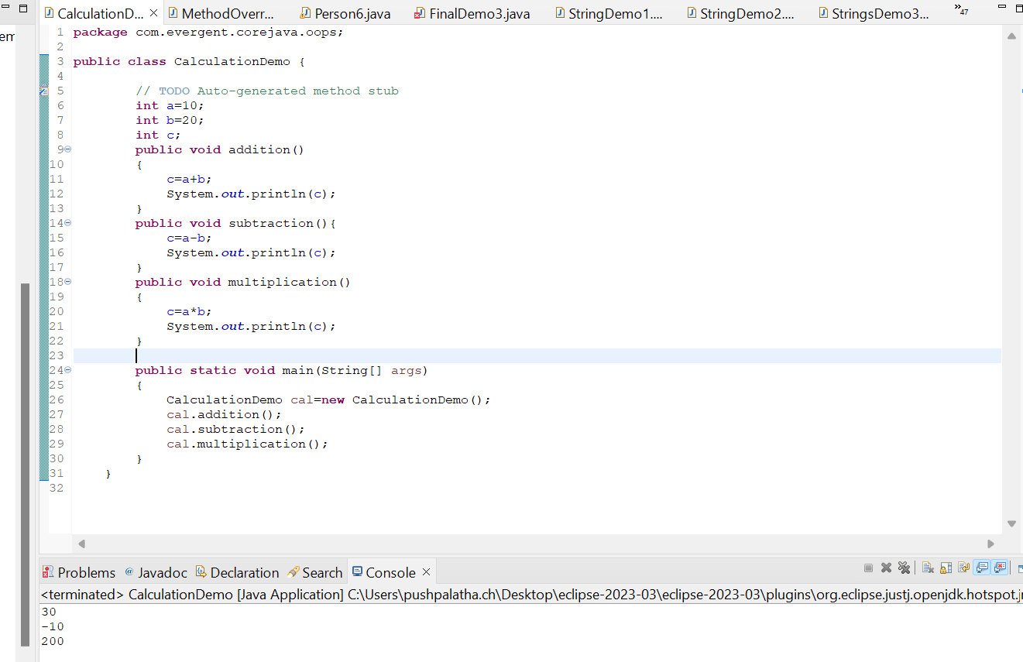

1. HAS_A(based on object creation we can call the method from the class)

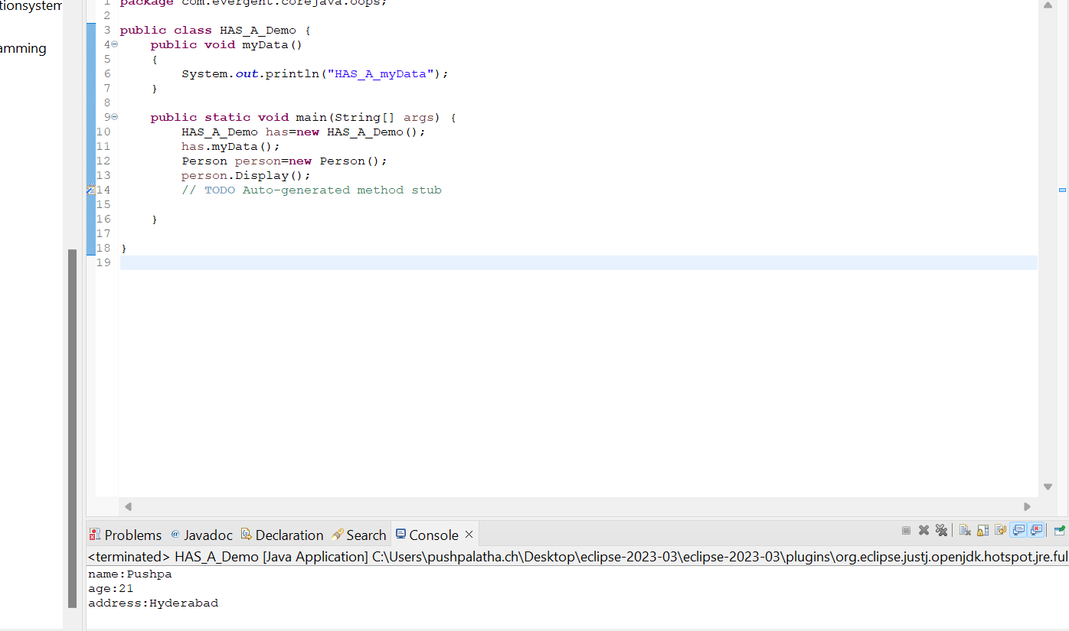

1. Inheritance(Re-usability of existing functionalities from super class to subclass)

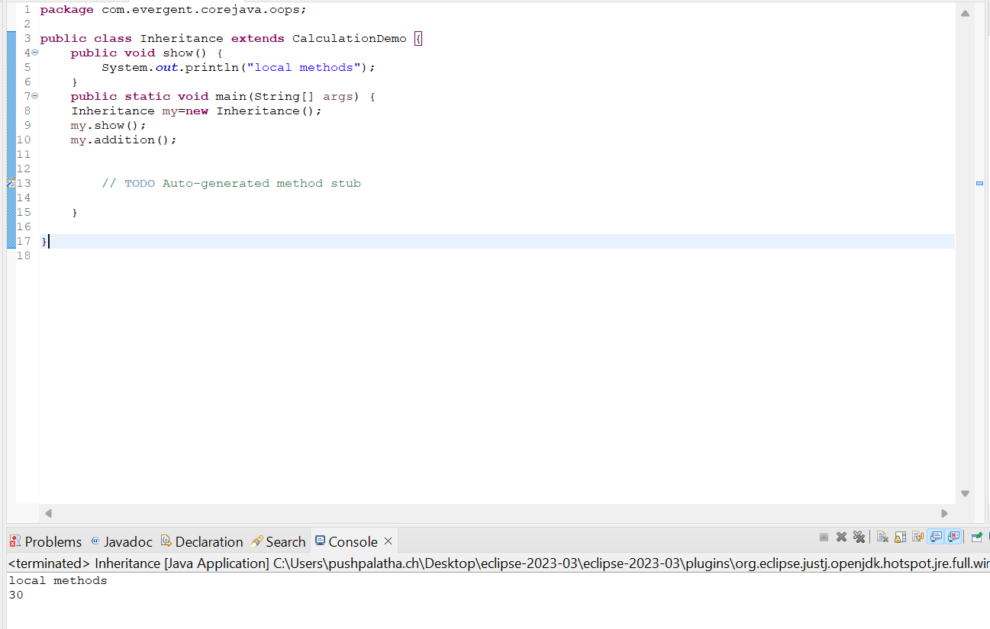

1. MethodOverriding(run time polymorphism-with same name,same number of parameters with same return type)

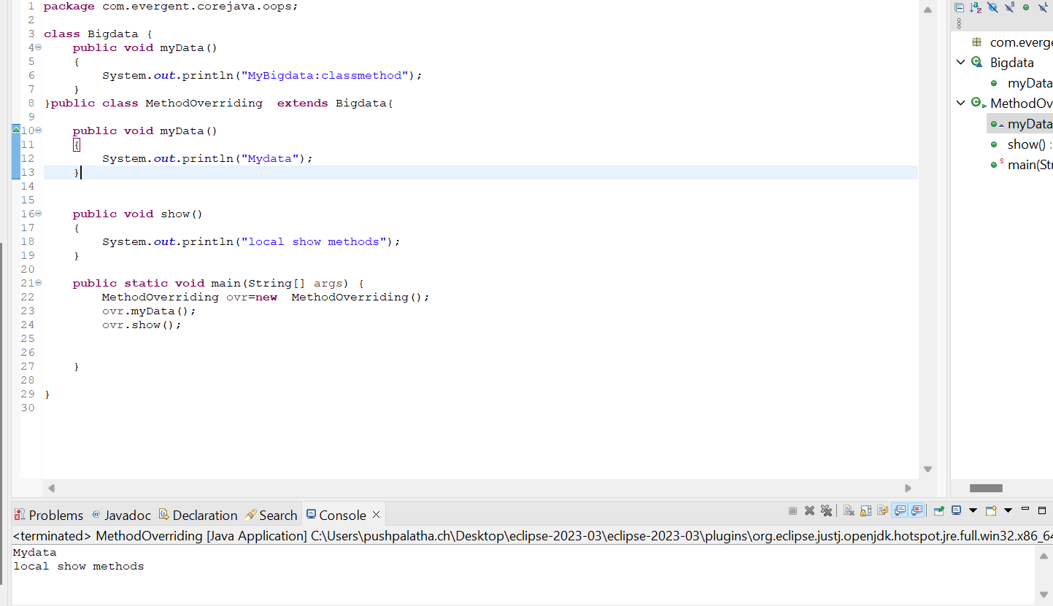

1. Methods Flow

Basically we can call methods in four ways:

1)Methods with parameters without return type.

2)Methods with parameters with return type.

3)Methods without parameters without return type.

4)Methods without parameters with return type.

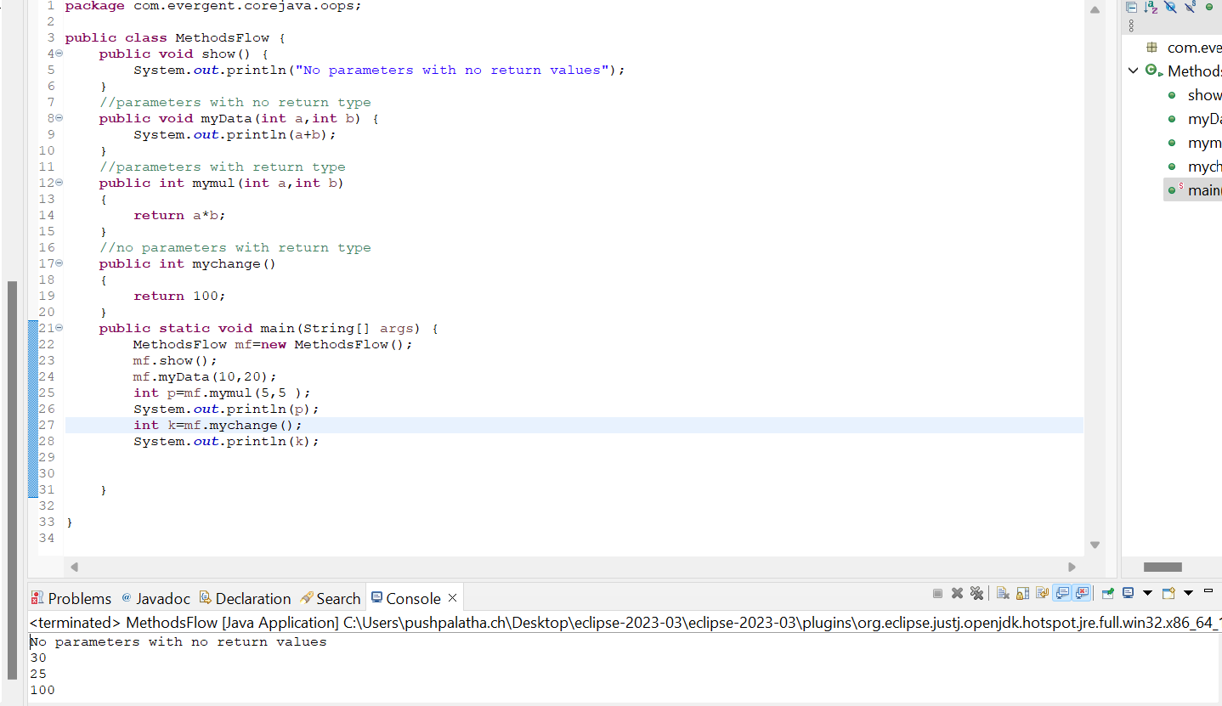

6.Multi Level Inheritance

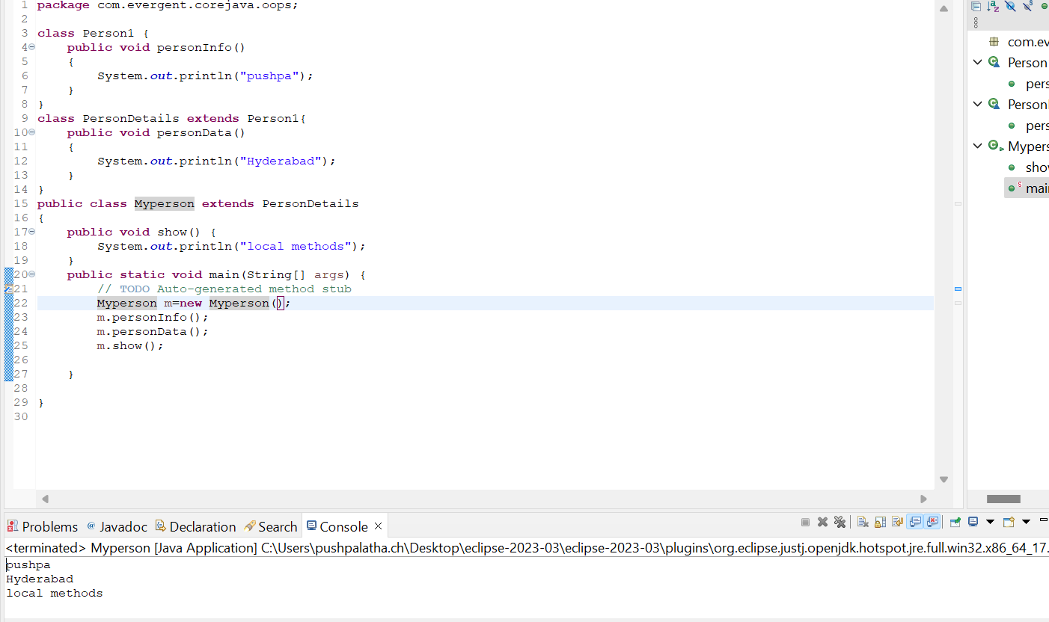

1. OOPS concept Example

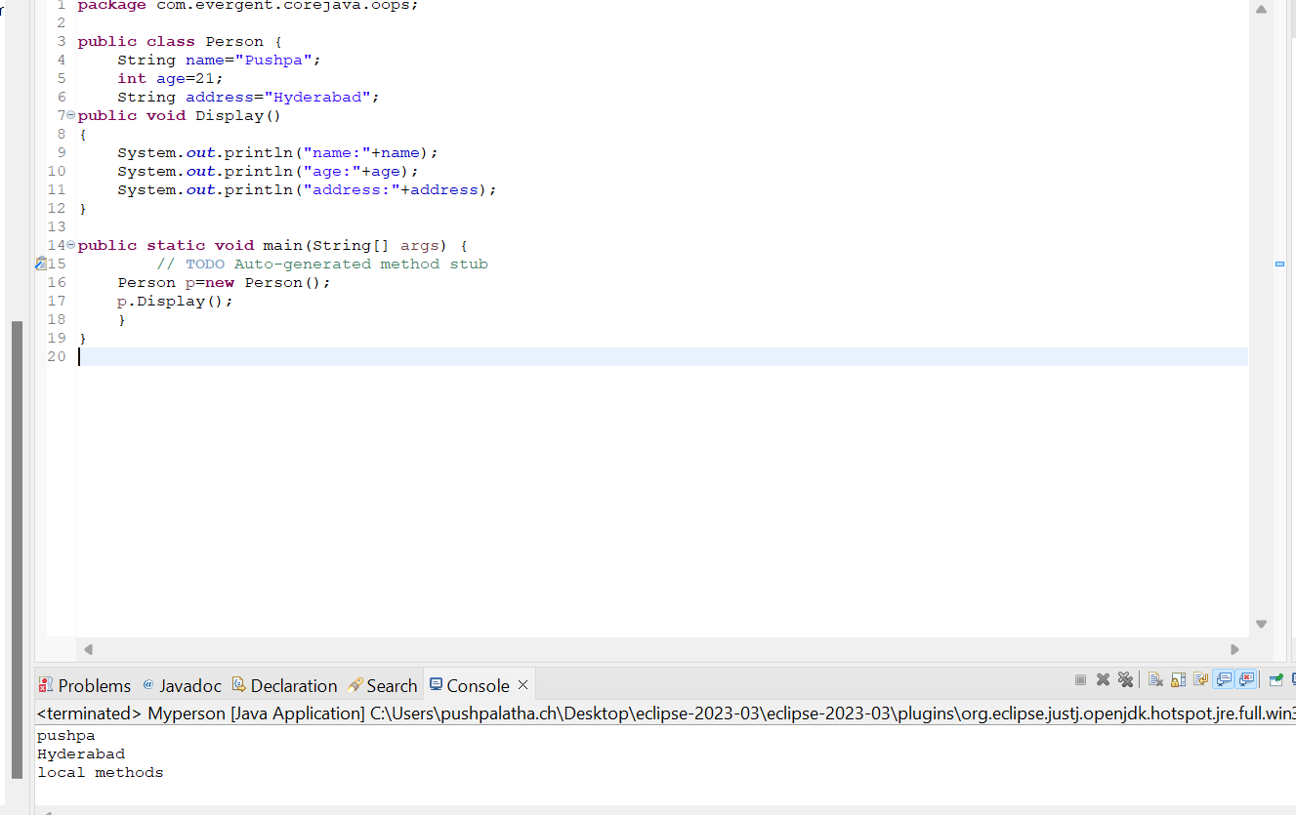

1. Method Overloading(compile time polymorphism-with same name,different number of parameters with may or may not be the same return type)

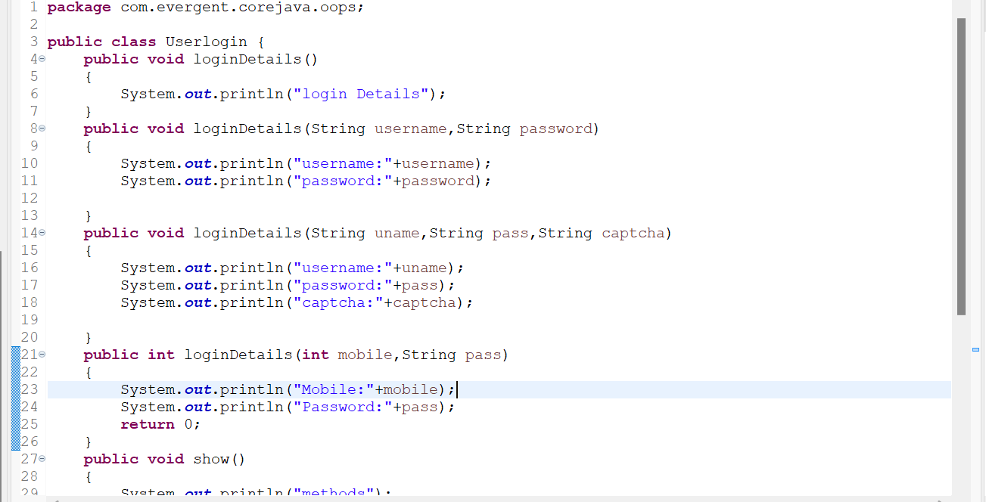

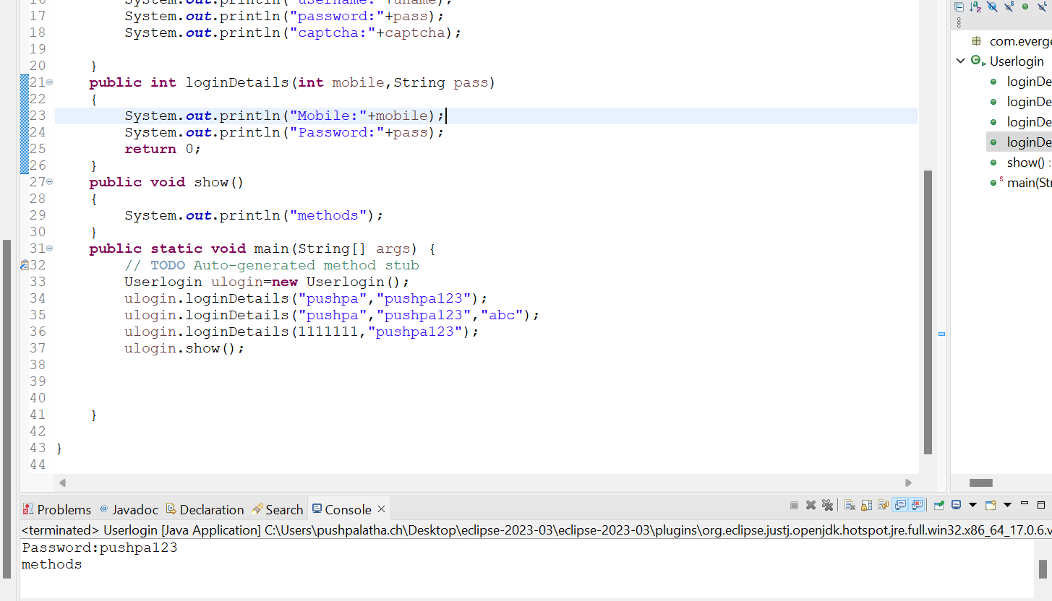

c.Exception handling

d.Multithreading

e.web application

f.open source

g.security

h.supports networking

i.memory management

3. JDK,JRE,JVM

4.Basic programming

Biggest of 2 numbers

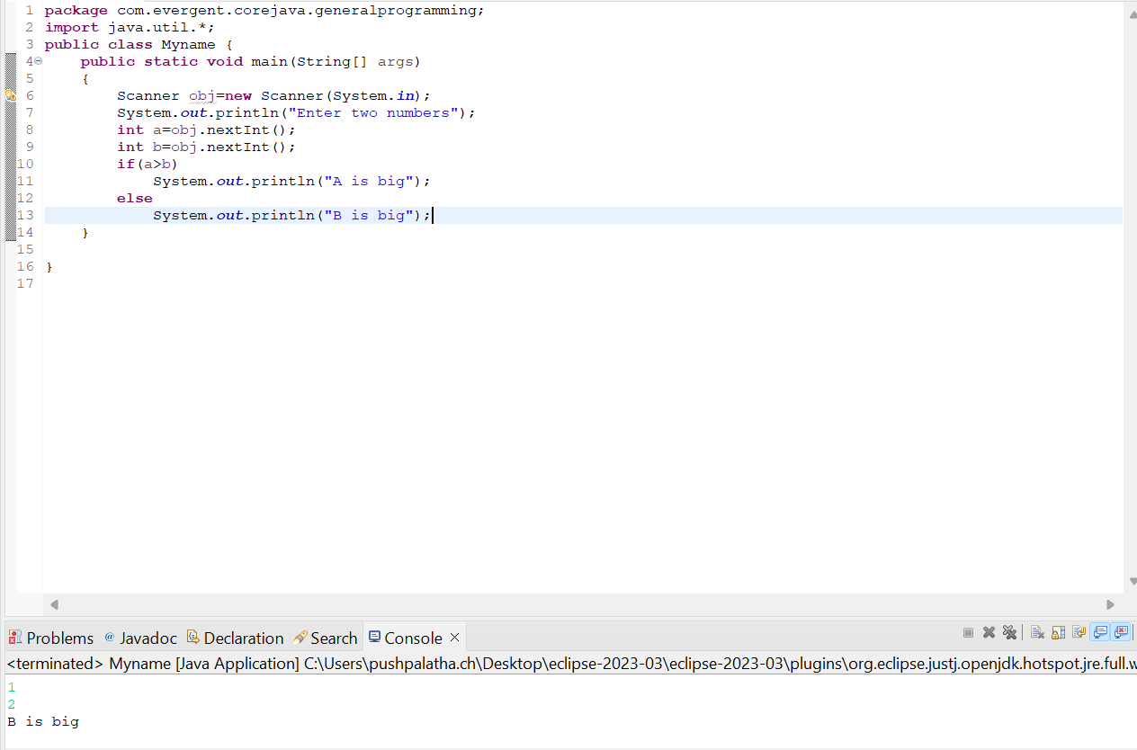

Biggest of 3 numbers

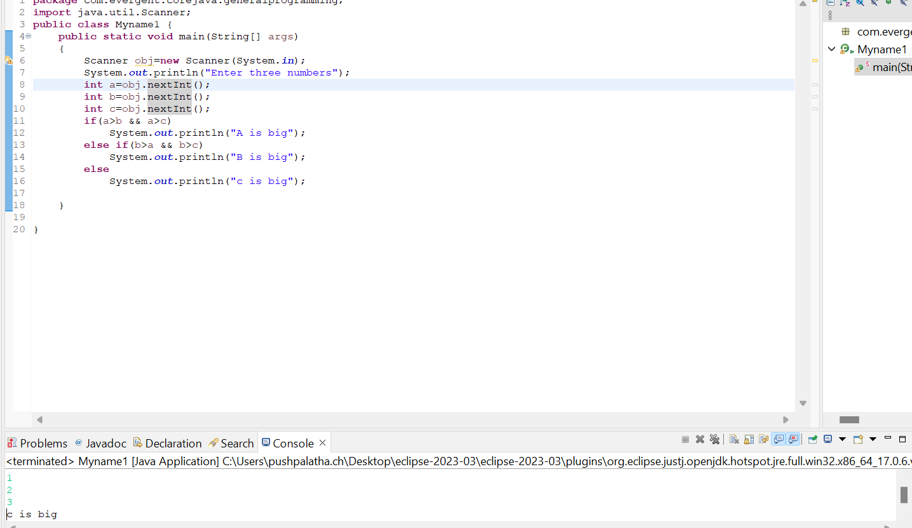

Biggest of 5 numbers

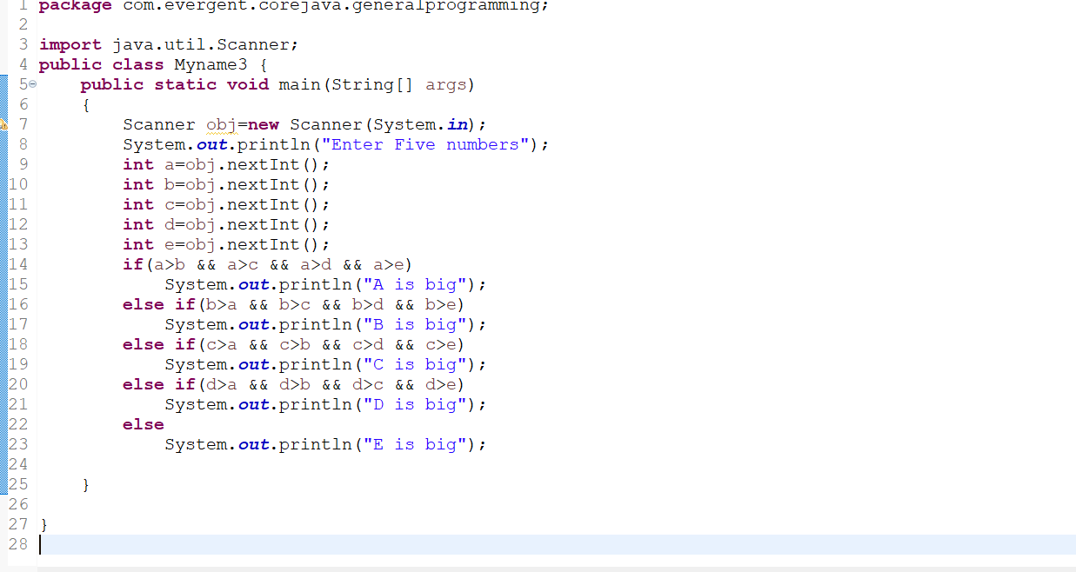

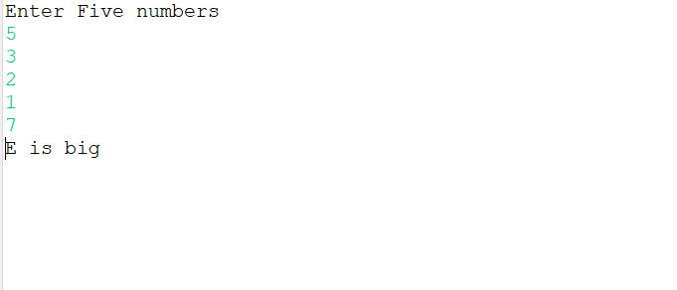

Print Addition and name

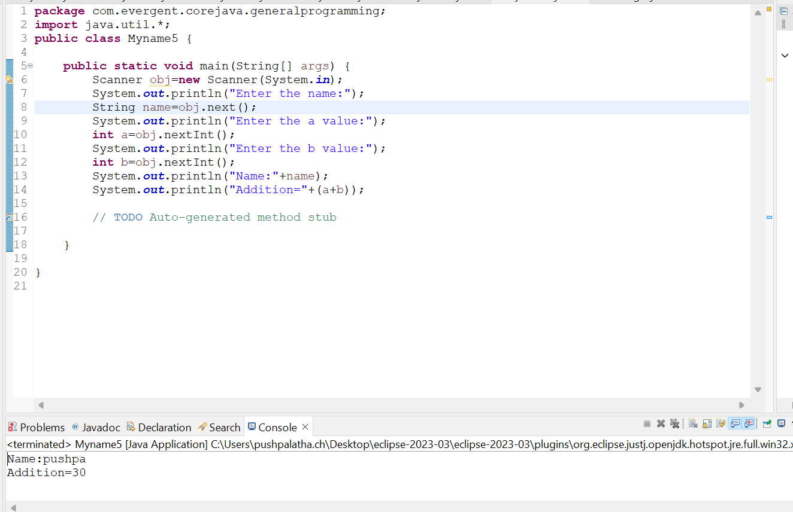

Swapping of 2 numbers without and with temp

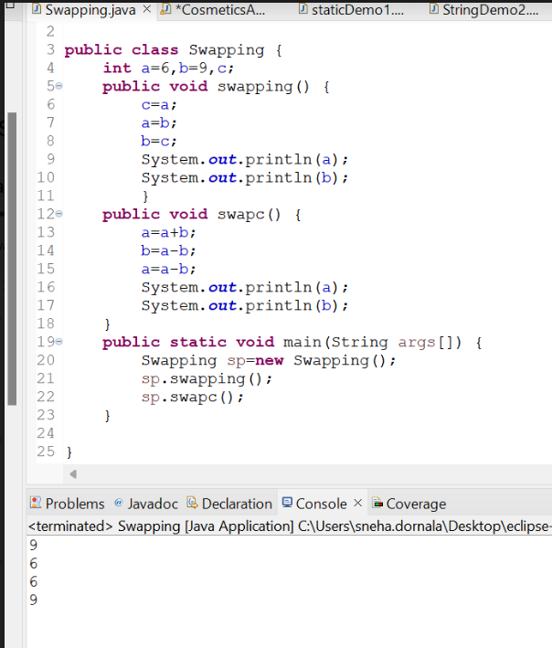

5.Packages.

********************************************

**Date:06/08/2024**

**Day-2**

1. Nested loops

1.Pattern1

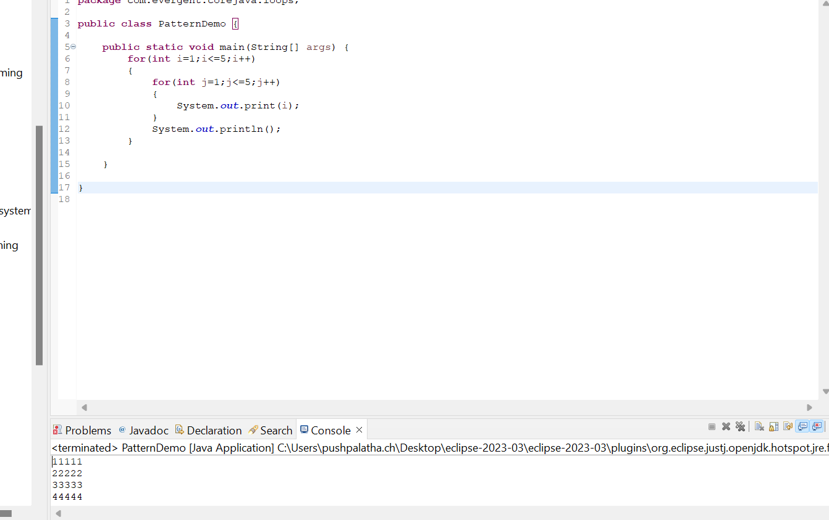

Pattern 2

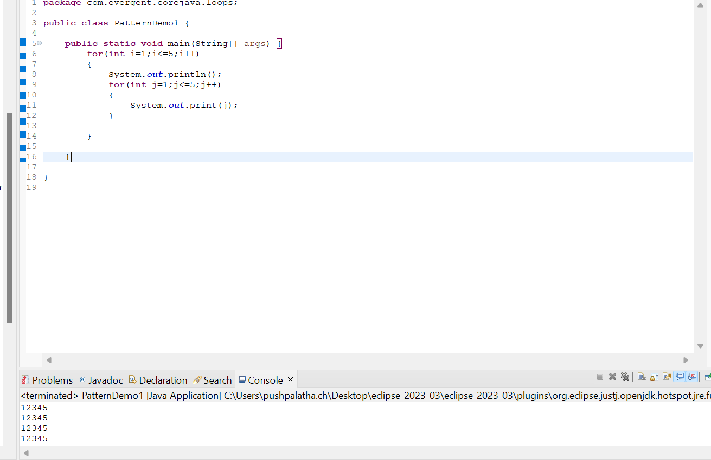

Pattern 3

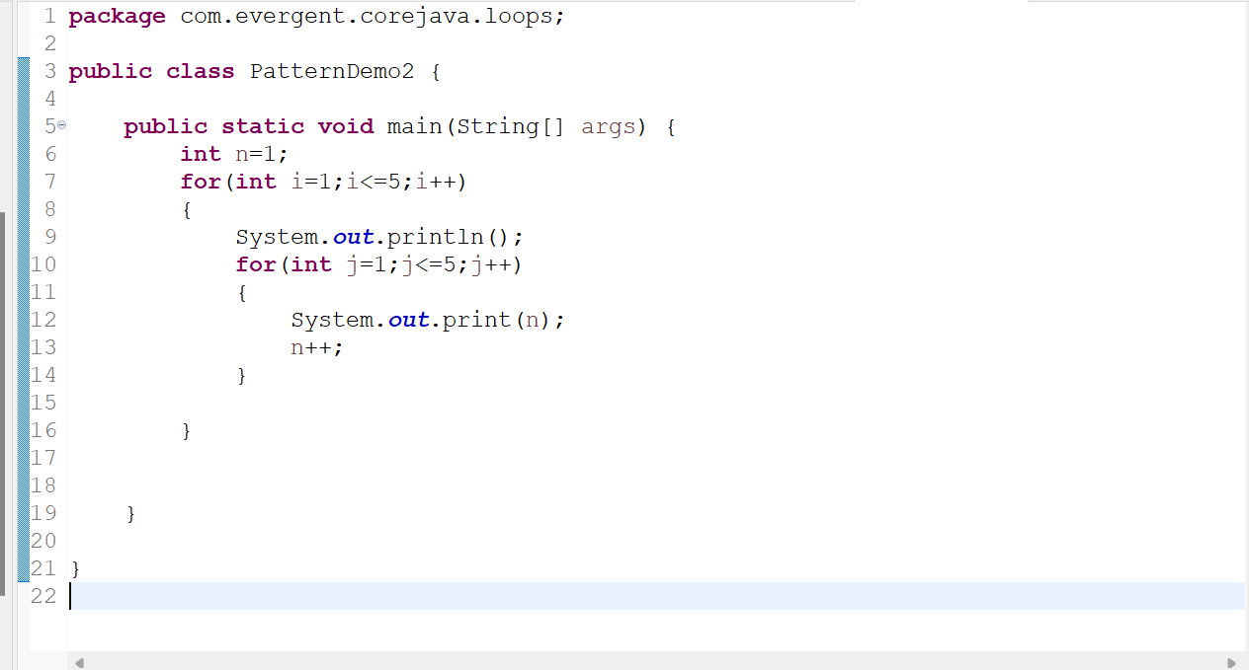

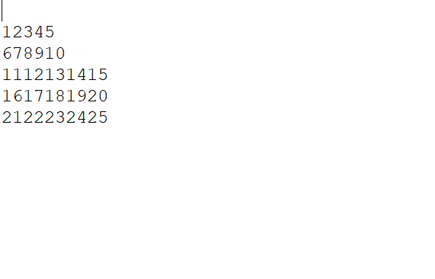

Pattern 4

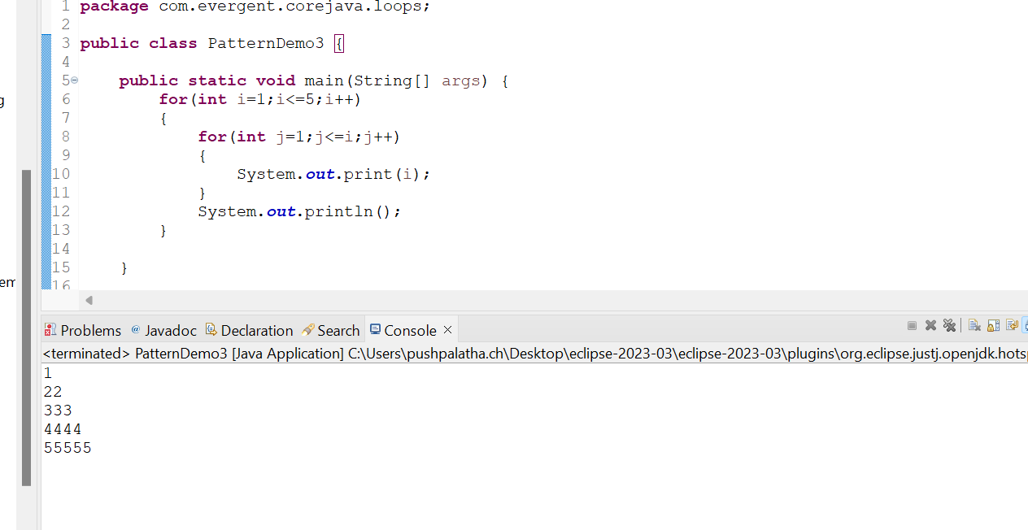

Pattern 5

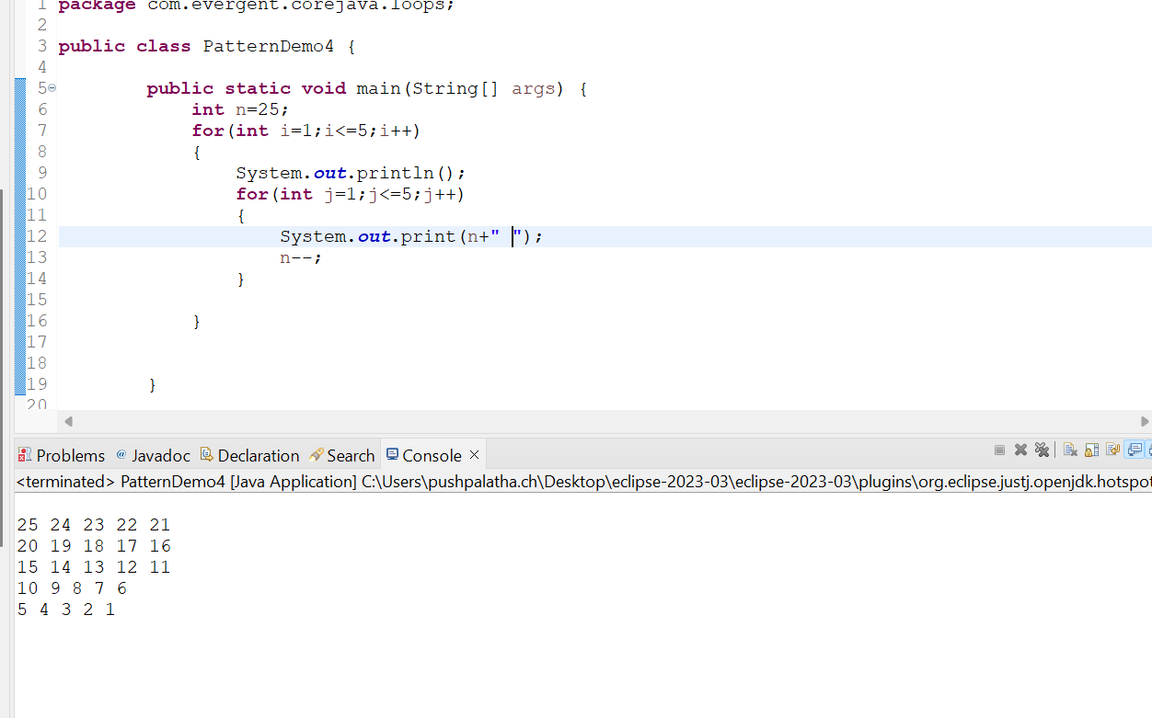

2.Arrays(collection of Homogenous data types stored in contiguous memory allocation with fixed size.)

a.single dimensional array

b.double dimensional array

Array1(initializing,retriving of data in single dimensional array)

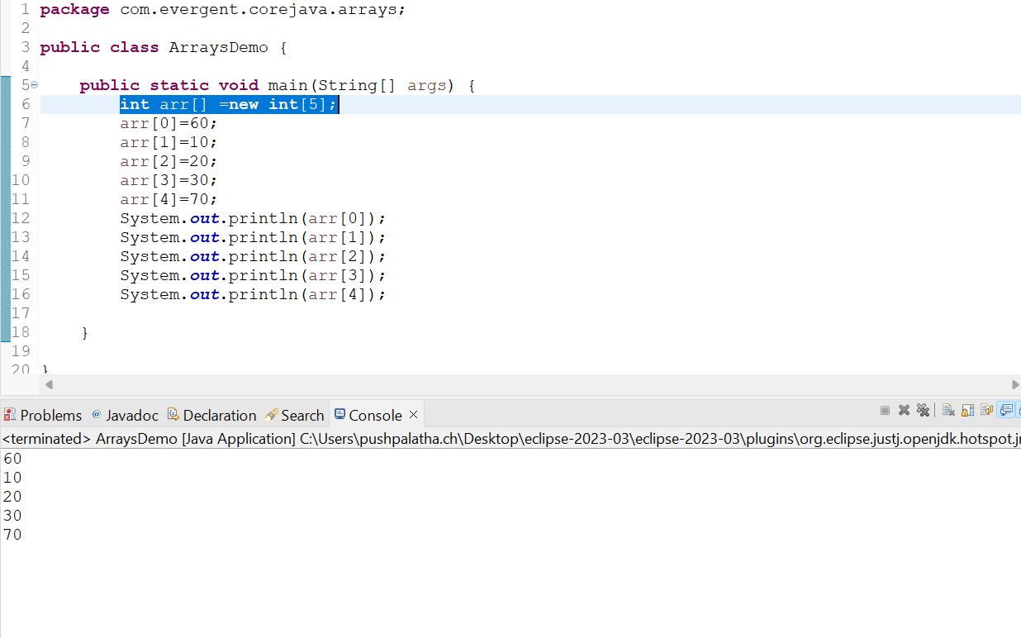

Array2(using for loop traversing the data in single dimensional array)

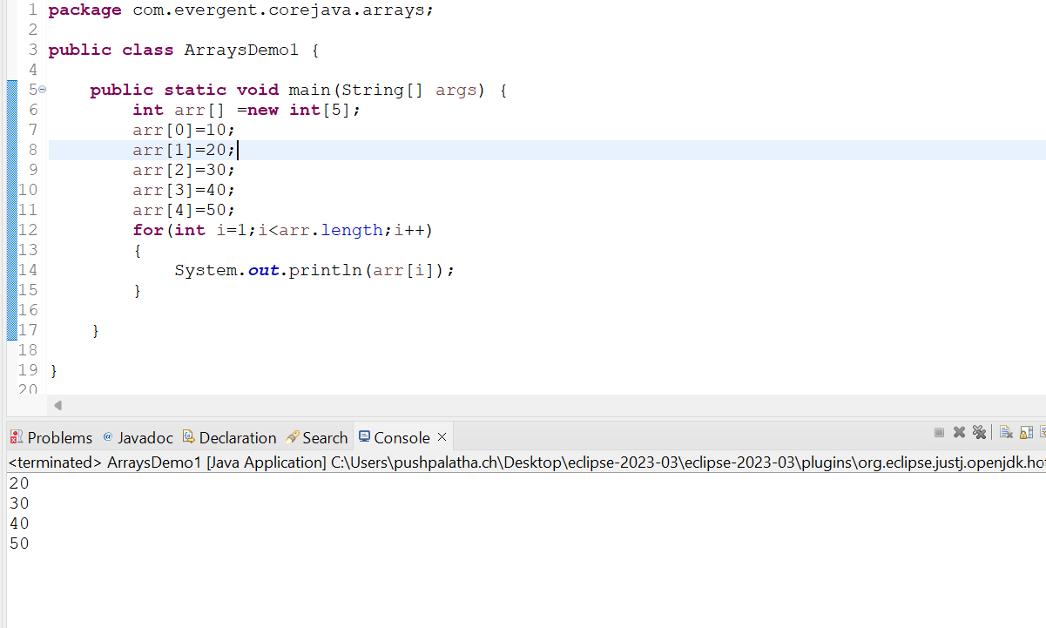

Array3

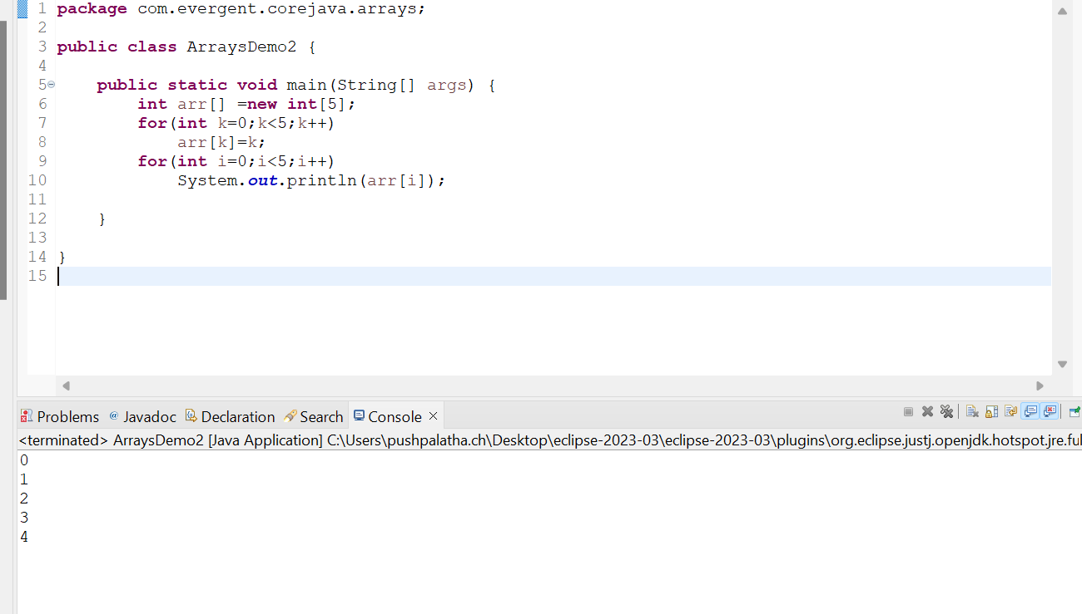

Array4

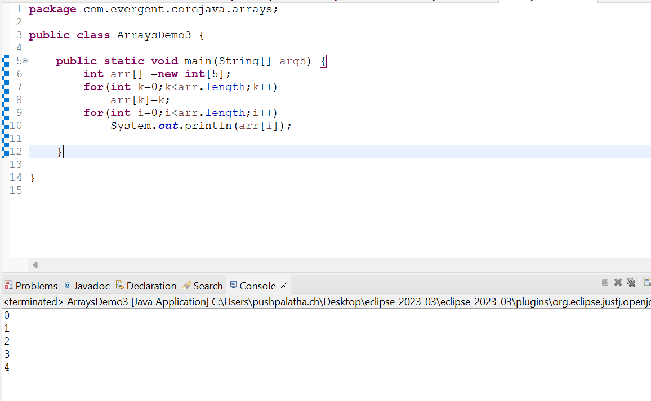

Array5



Array 6(Multidimensional Array)

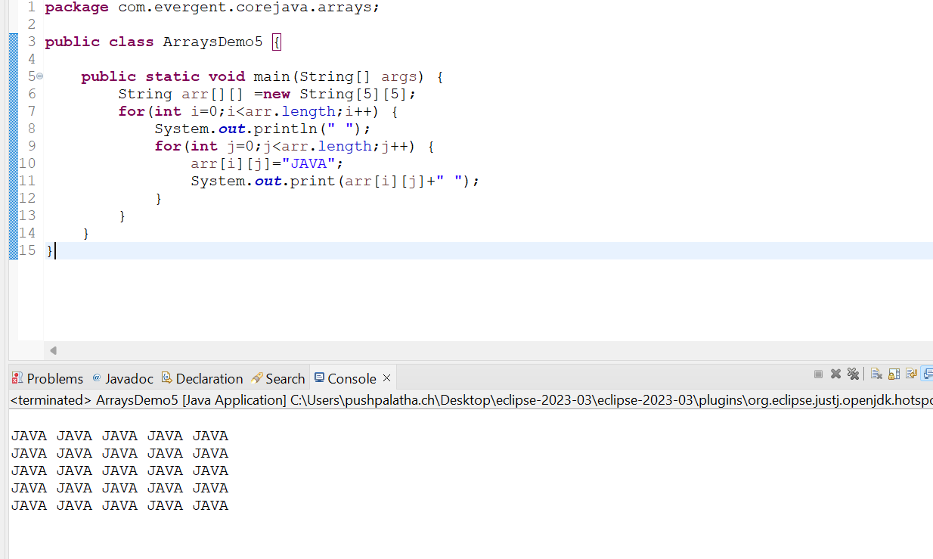

Array 7(Multi dimensional array)

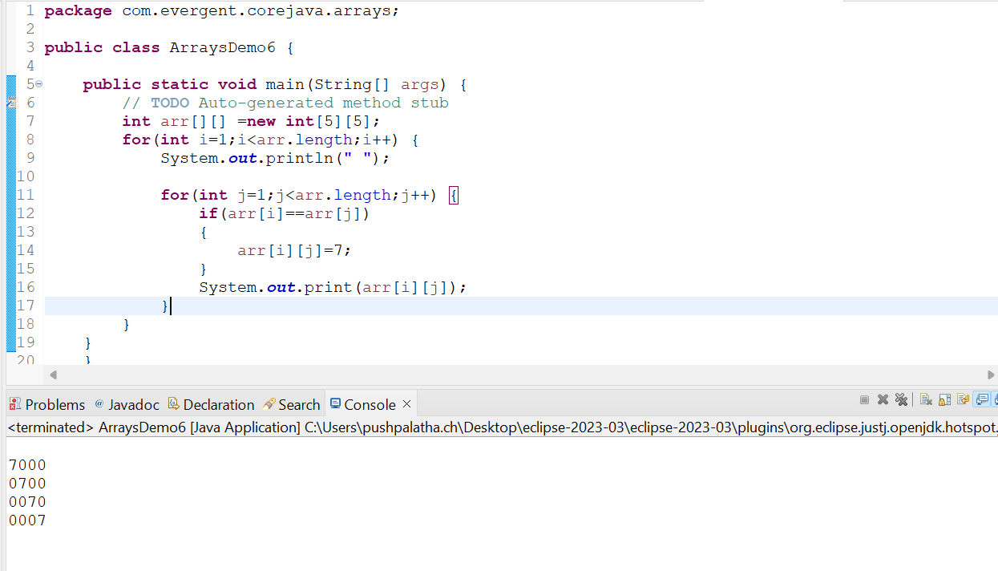

Array 8(Multi dimensional Array)

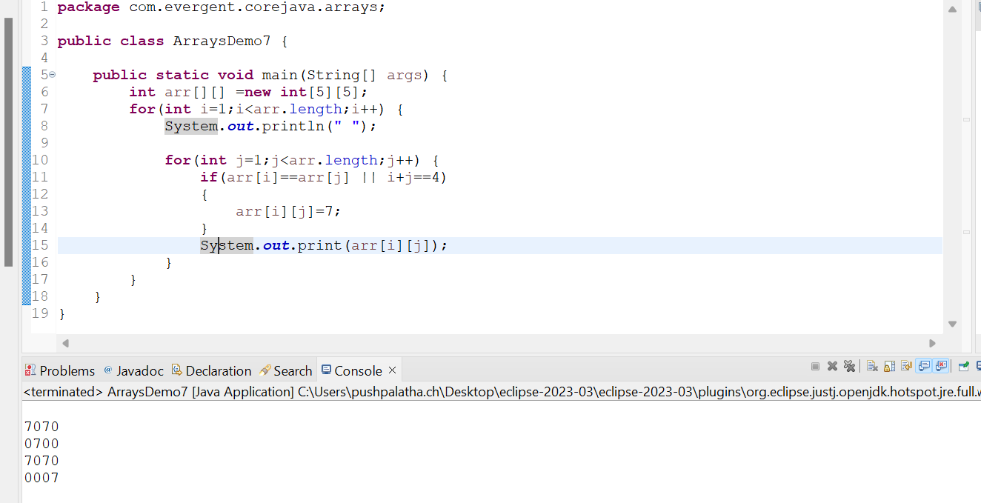

Array 9(Multi dimensional Array)

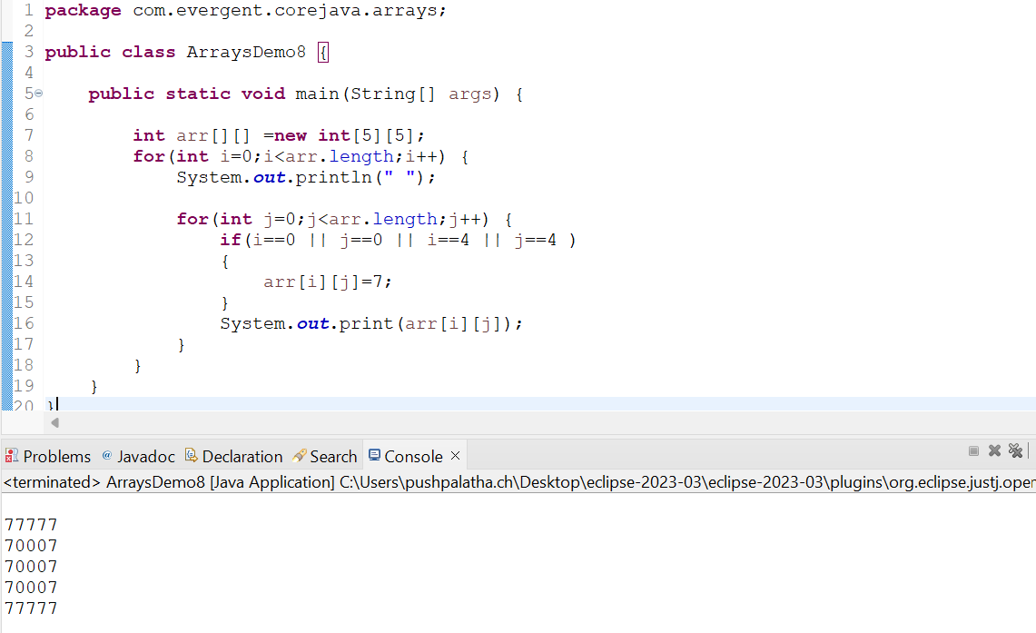

1. Logical programming

Factorial program

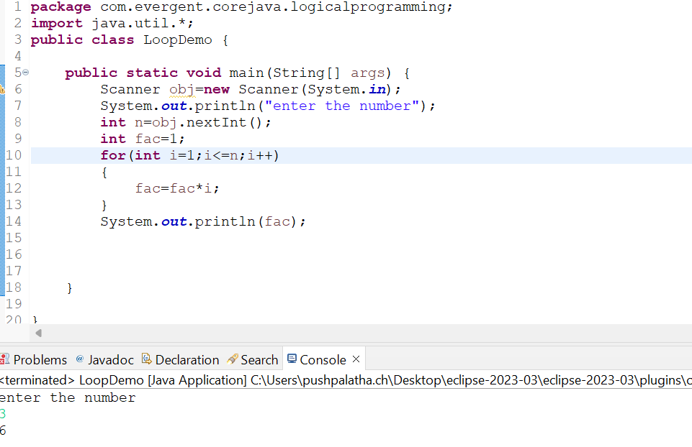

Fibonacci series program

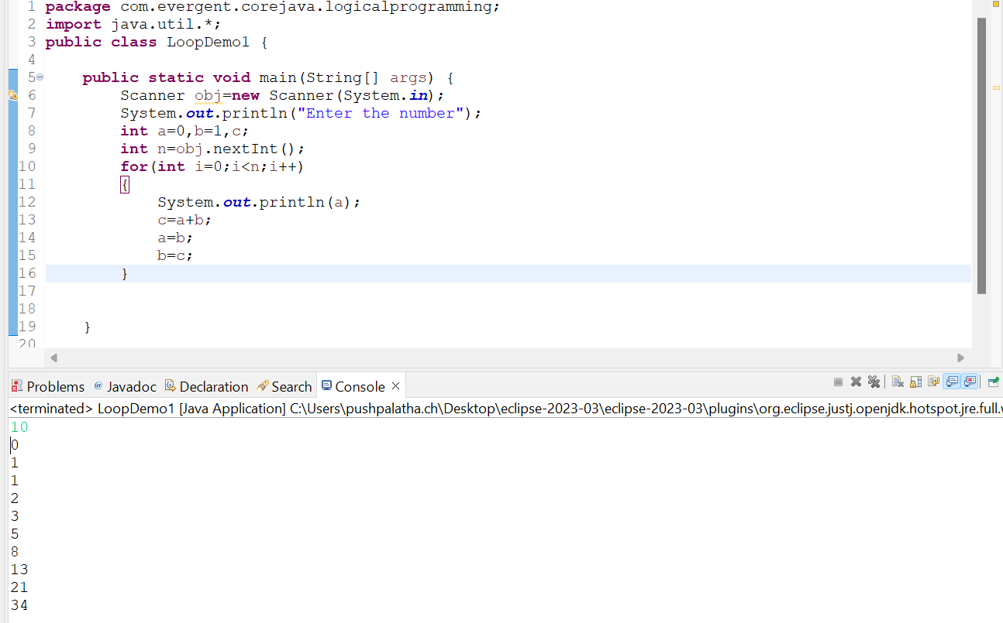

1. Switch case

5.Scanner class

6.Enum

Enum Example

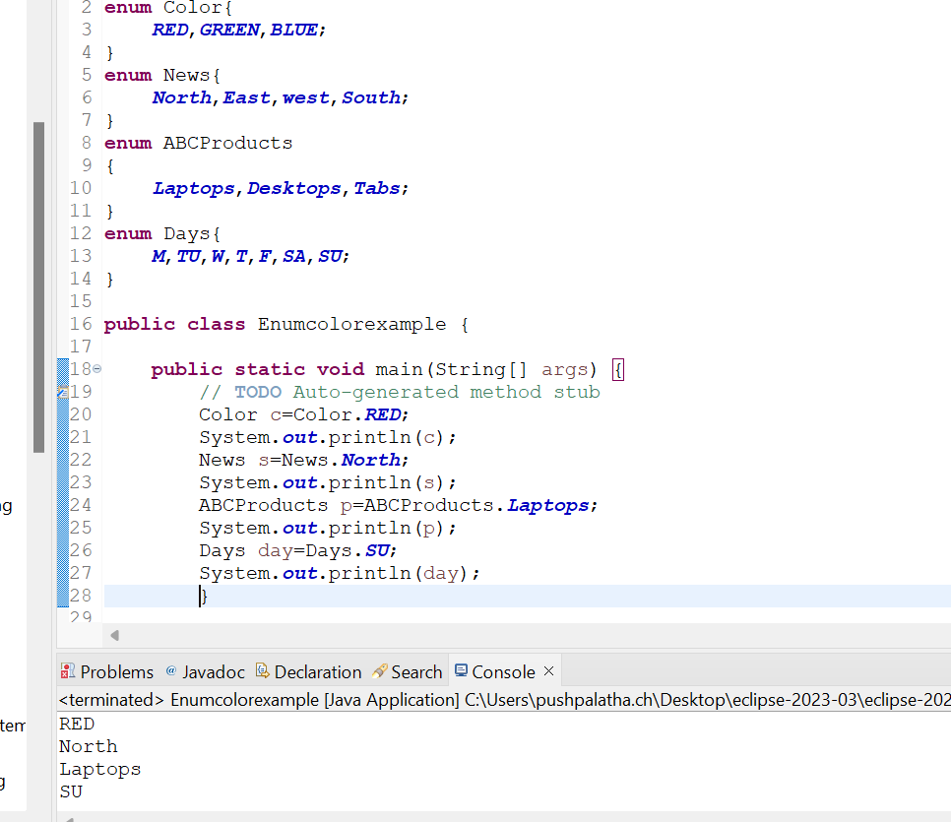

7.event management system application

8.Object class methods

* equals()
* toString()
* getClass()
* finalize()
* clone()
* wait()
* notify()
* notifyAll()

******************************************************

**Date 07/08/2024**

**Day-3**

1.Started OOPS concepts,

a.Encapsulation,

b.Inheritance,

c.Polymorphism (method overloading and method overriding) with example programs

d.method flows with suitable example program,

e.Is-A & Has-A relationships.

***********************************************************

**Date 08/08/2024**

**Day-4**

**Constructors**

1. Class name and constructor name should be same.
2. There are 2 types of constructors

Default constructor

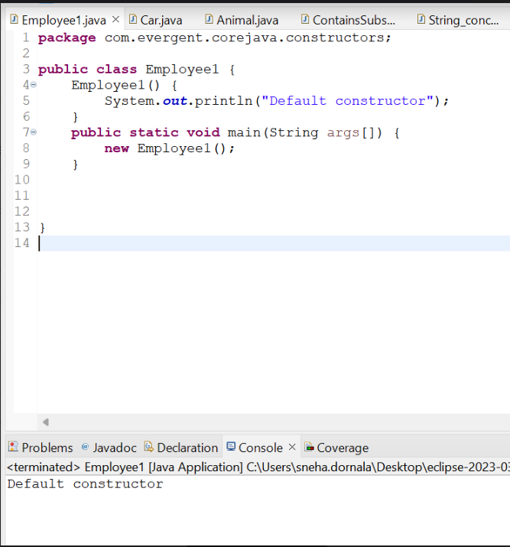

Parametrized constructor

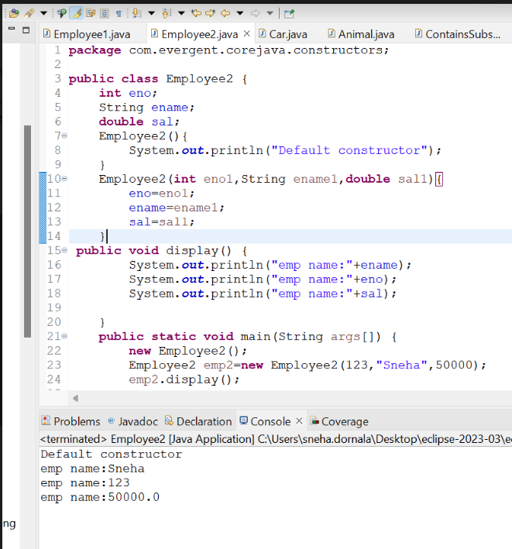

1. We can access constructors while creation of objects.
2. Constructors are mainly for intializing the objects.
3. Constructors does not any return type not even void also .If we declare as a void it will consider as a method not as constructor.

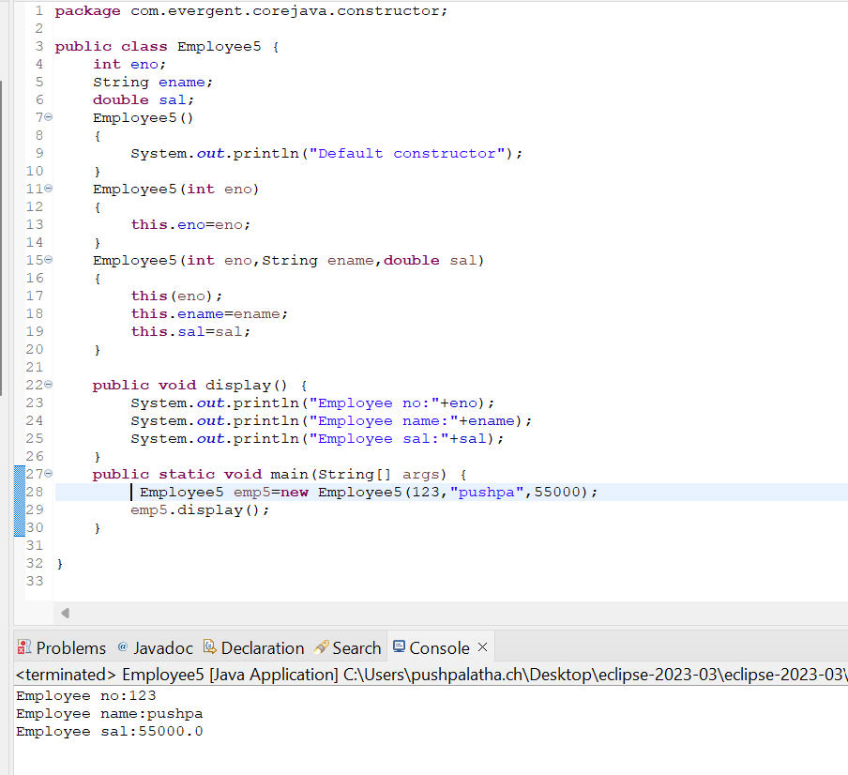

1. Every Class Contains atleast one default constructor Either we will create or JVM will generate at the time of compilation.
2. this and super Keywords.

this(this is generally always pointing to instance variables and used to call current class constructor within the class)



Super(Super keyword is used to call super class constructor in constructors)

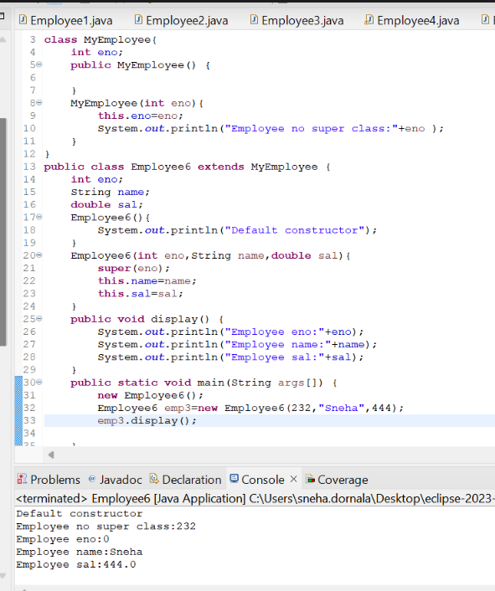

1. Object copy constructor.

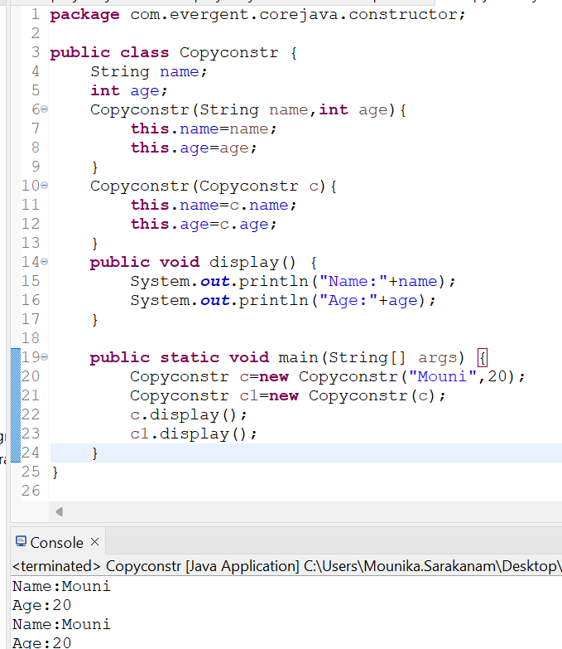

1. Always Constructors are overloaded.
2. We can call one Constructor to another constructor through this keyword.
3. We can intialize values to default constructor.

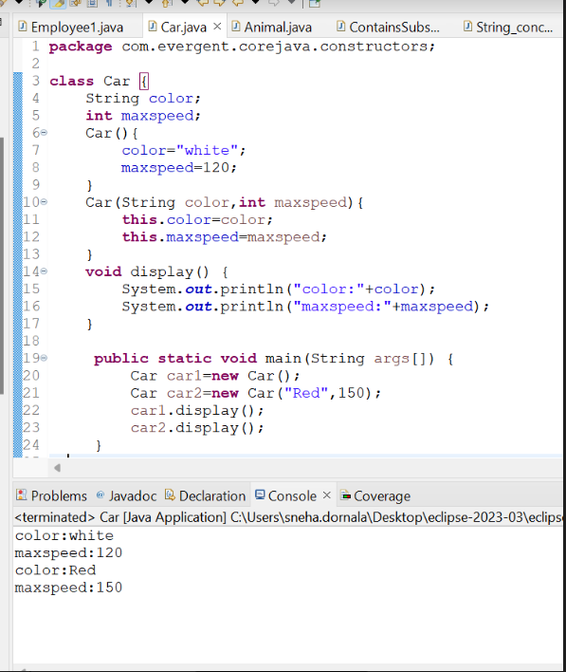

ConstructorOverloaded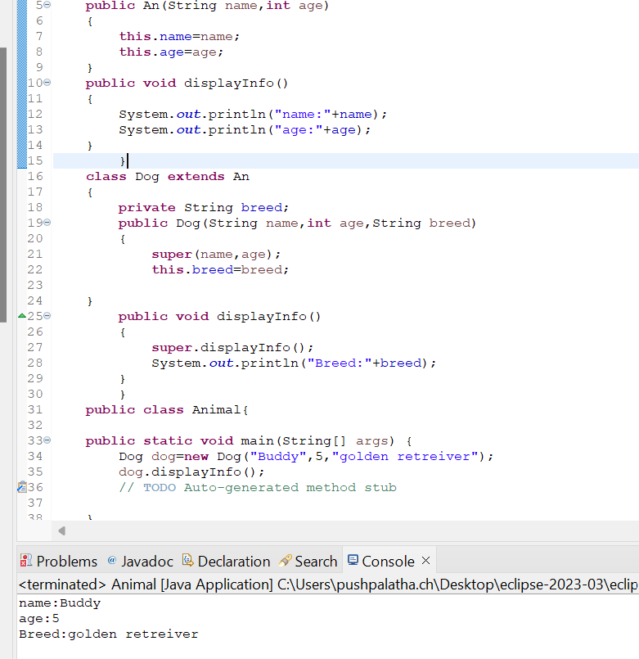

**Static keyword**

Static is a variable

We can declare static as variables,methods

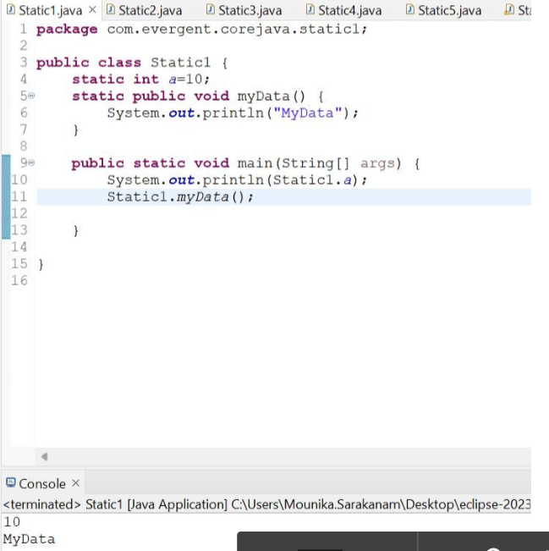

Inside static method we cannot access non static variables or methods.

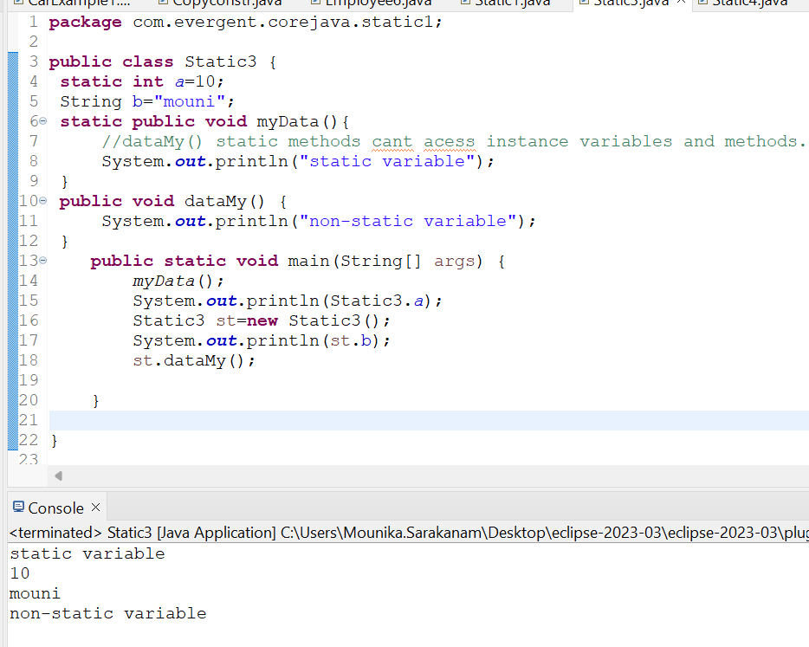

Inside non static method we can use static methods or variables.

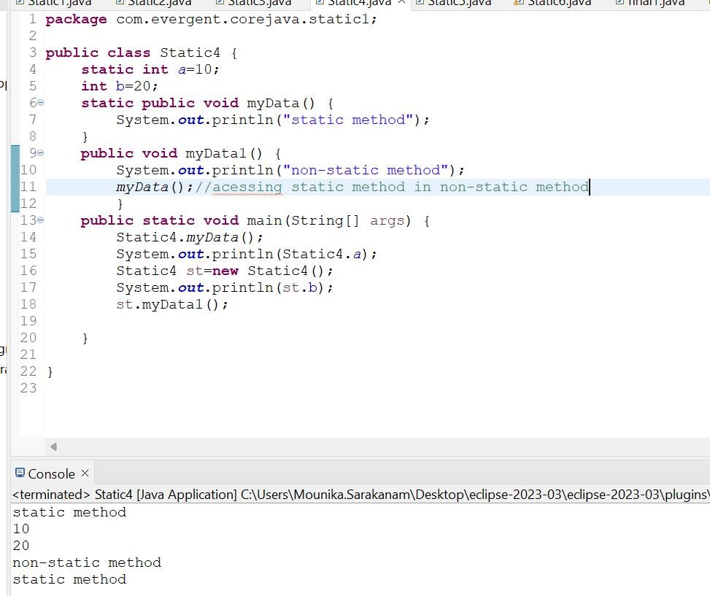

Static block is executed automatically without calling the block in the main method.static block is compiled durring the execution of class.At first static block is executed then remaining main method,classes,etc will be executed.

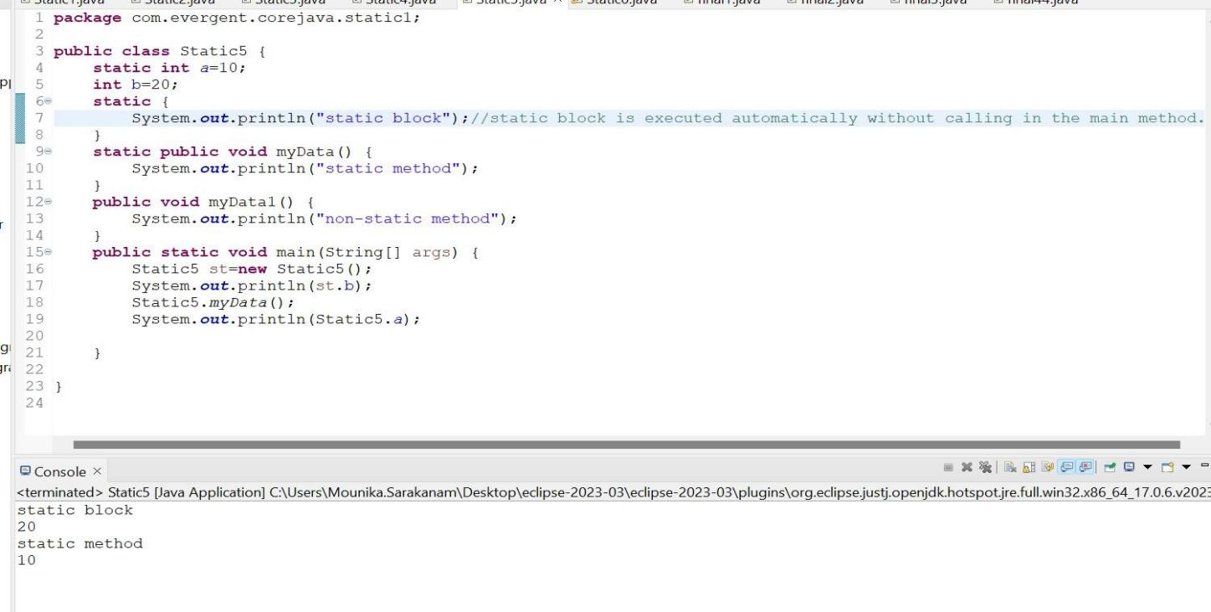

Example for static

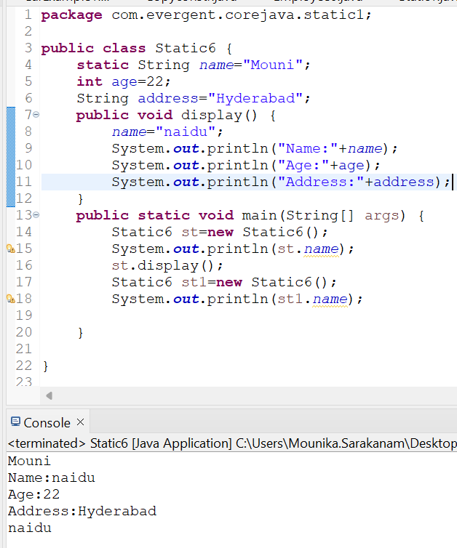

# final

final is a keyword

final can be declared as variable,method,class

If variables are declared as final those are treated as constants cannot be modified after.

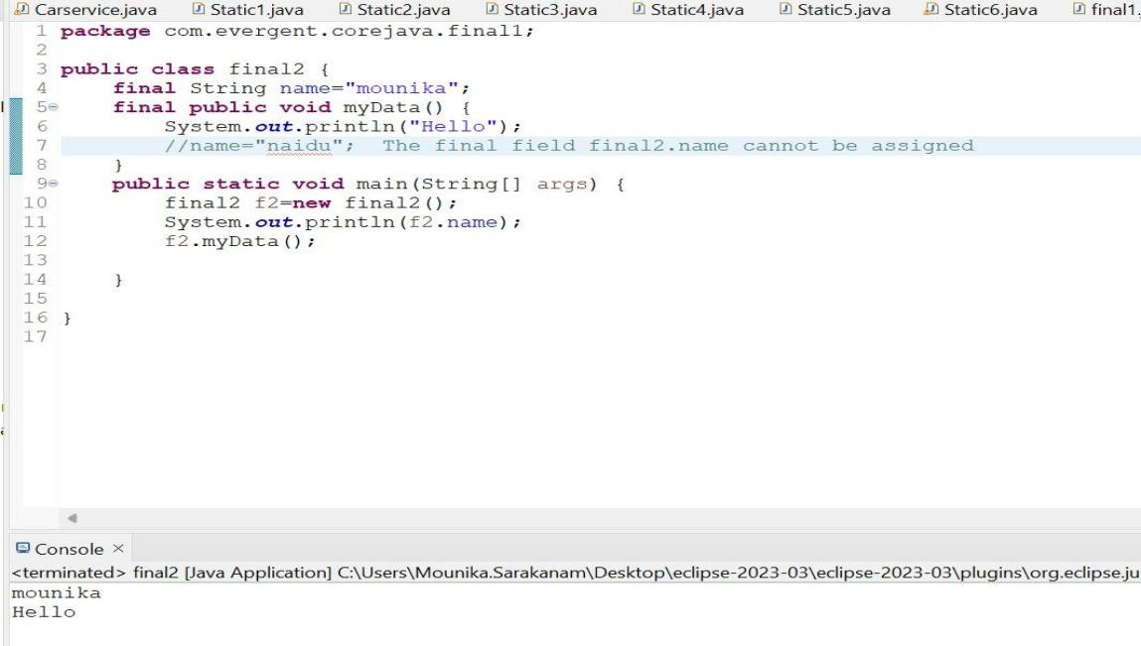

If the class is declared as final we cannot inherit

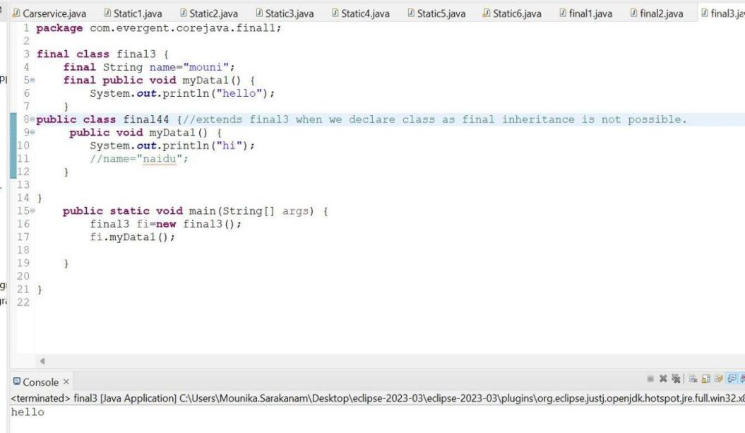

If the method is declared as final we cannot overriden.

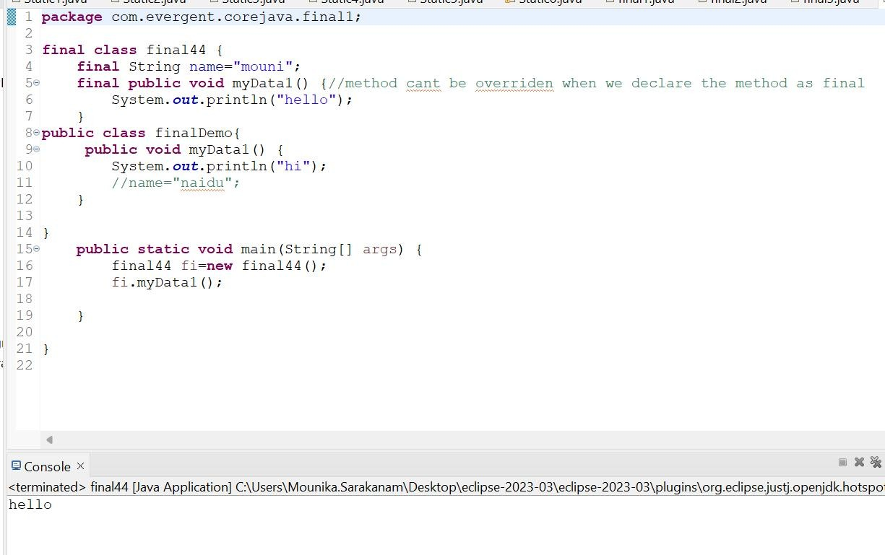

STRINGS

-String is a sequence of characters.

|  |  |  |
| --- | --- | --- |
| String | StringBuffer | StringBuilder |
| Is a final class(can’t extend) | Is a final class(can’t extend) | Is a final class(can’t extend) |
| Immutable(can’t modify) | Mutable(can modify) | Mutable(can modify) |
| Methods in String class are non-synchronized(not-thread safe) | Methods in StringBuffer class are synchronized(thread safe) | Methods in StringBuilder class are non-synchronized(not-thread safe) |
| Strings are used for Single update | StringBuffer is not recommended as it has legacy API | StringBuilder are used for multiple updates.It is started from JDK 1.5 |

String creation:

We can create String in two ways

1. Using new keyword.(Object is created for every new keyword even though the same data is present in the heap area)
2. Using String literal.(Object is created if and only if the keyword is not present in the String Constant pool.)

String str1=new String(“JAVA”);

String str2=new String(“JAVA”);

String s1=”JAVA”;

String s2=”JAVA”;

String constant pool

JAVA

JAVA

JAVA

String class

* String is a final class.
* Strings are immutable.
* String class consists of methods.
* Methods in String class are non-synchronized.

1. Creating String using new keyword.

equals() in String used to check the content.

== method in String is used to check the Memory location.

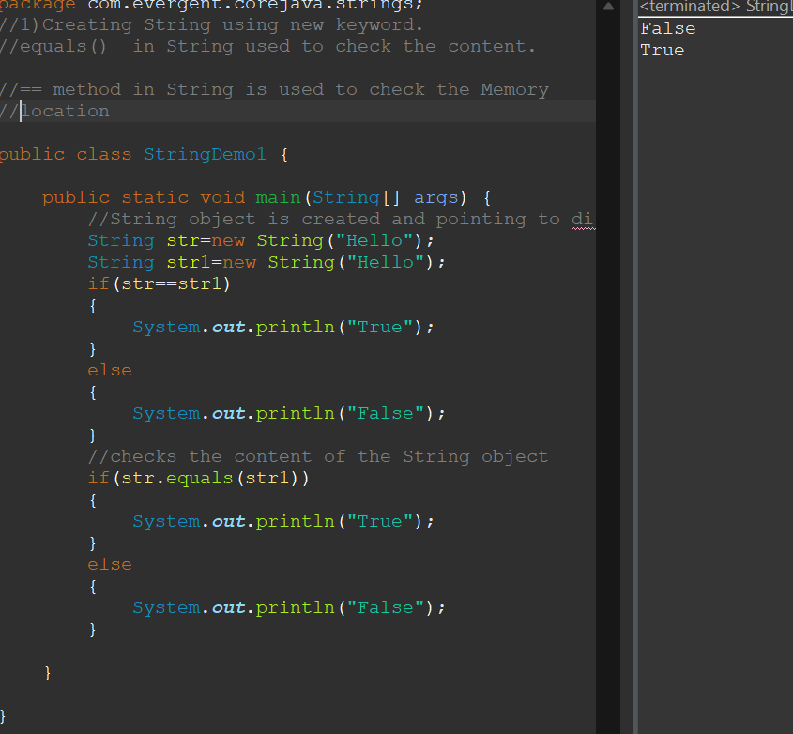

2)Creating String using literals

equals() in String used to check the content.

== method in String is used to check the Memory location.

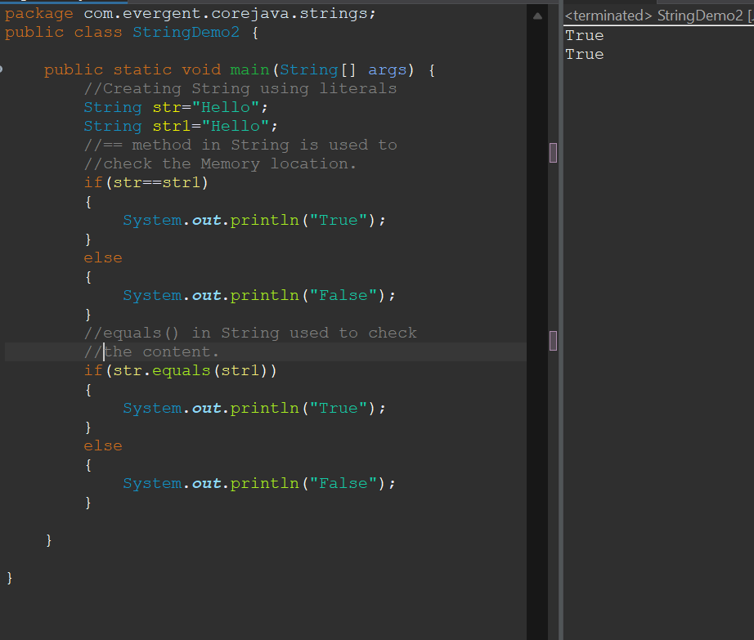

1. String methods (toLowerCase()-Changes the complete String into lowercase,
2. toUpperCase()-Converts the complete String into uppercase,
3. length()-To know the length of the String,
4. trim()-To remove the spaces before the String)

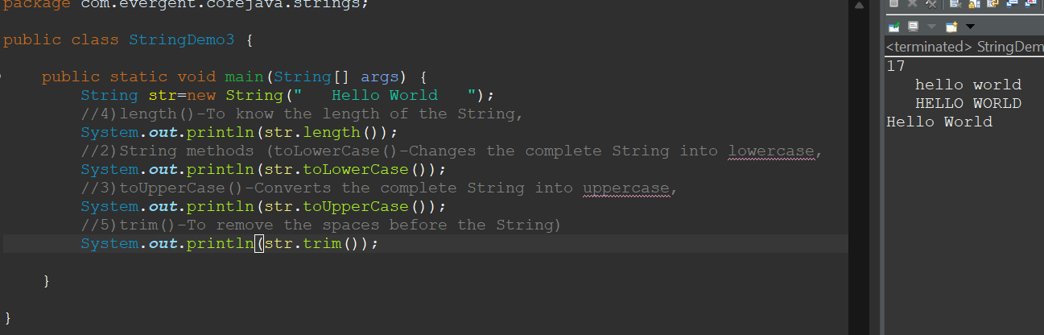

4)String method(contains()-to check whether the substring is present in the string)

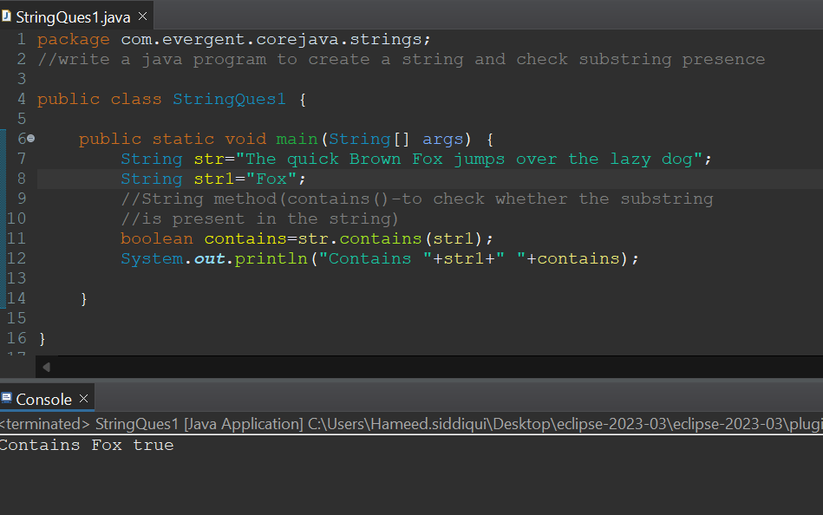

5)String method(replace()-to replace the values with other values)

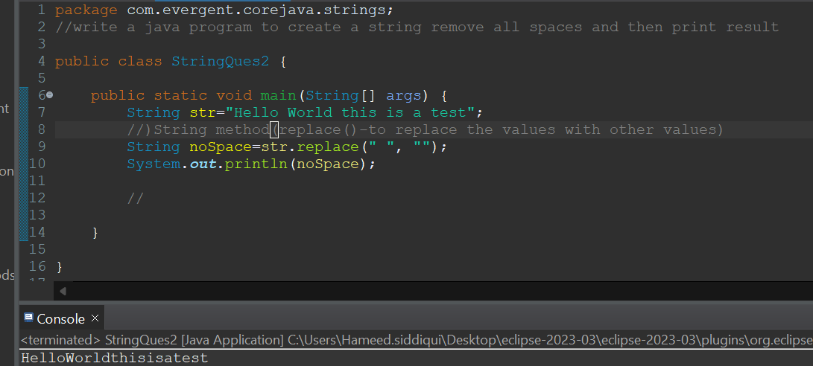

6)String method(reverse()-to reverse of the String)

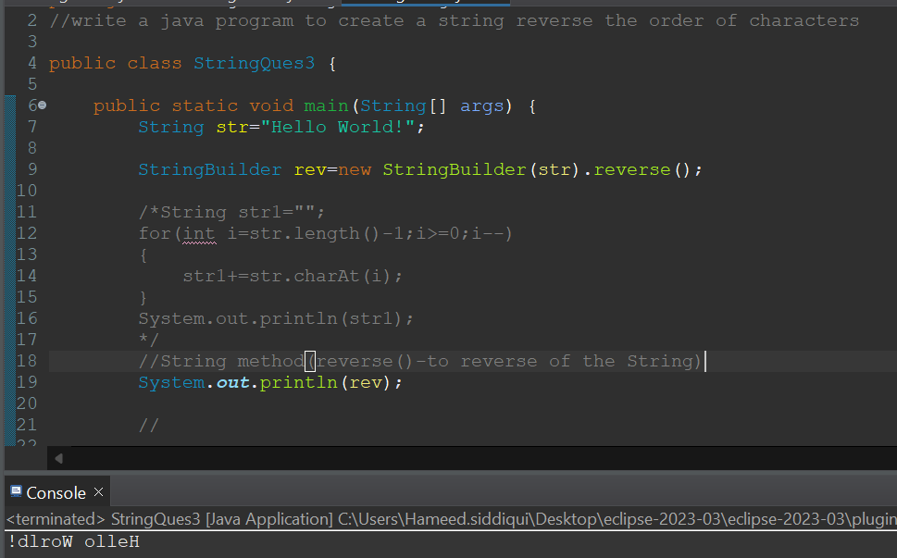

7)String method concat()-to combine two strings into one String

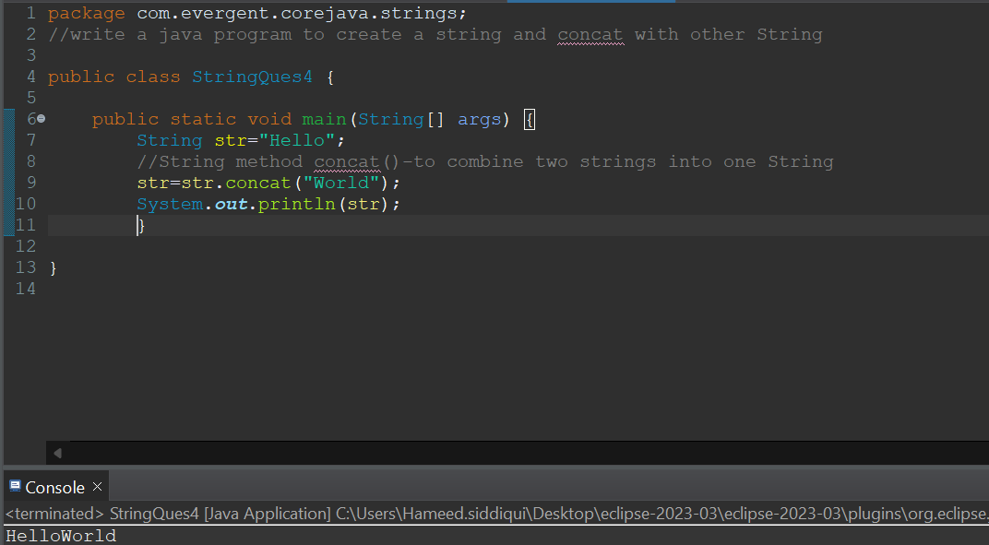

StringBuffer

* StringBuffer is a final class.
* StringBuffer are mutable.
* String class consists of methods.
* Methods in StringBuffer class are synchronized.

1. StringBuffer methods(append()-used to combine the two strings into one String,

Insert-to insert the string into the present string based on the index value,reverse-to reverse the string ,replace-replace the string with other string based on starting index and ending index,delete-to delete the sub string or string from the existing string based on starting index and ending index.)

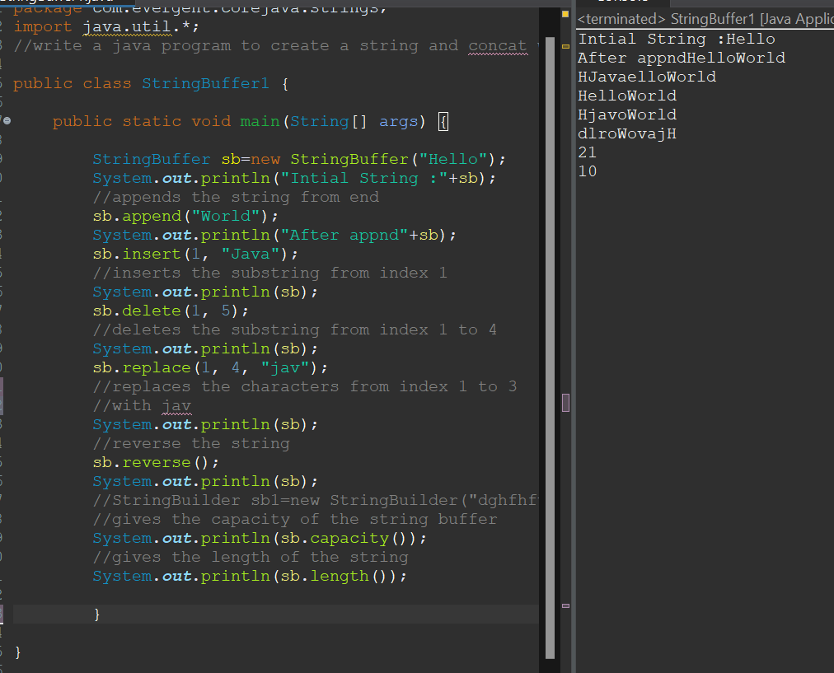

StringBuilder

* String Builder is a final class.
* StringBuilder are mutable.
* StringBuilder class consists of methods.
* Methods in String class are non-synchronized.

1. 1)StringBuilder methods(append()-used to combine the two strings into one String,Insert-to insert the string into the present string based on the index value,reverse-to reverse the string ,replace-replace the string with other string based on starting index and ending index,delete-to delete the substring or string from the existing string based on starting index and ending index.)

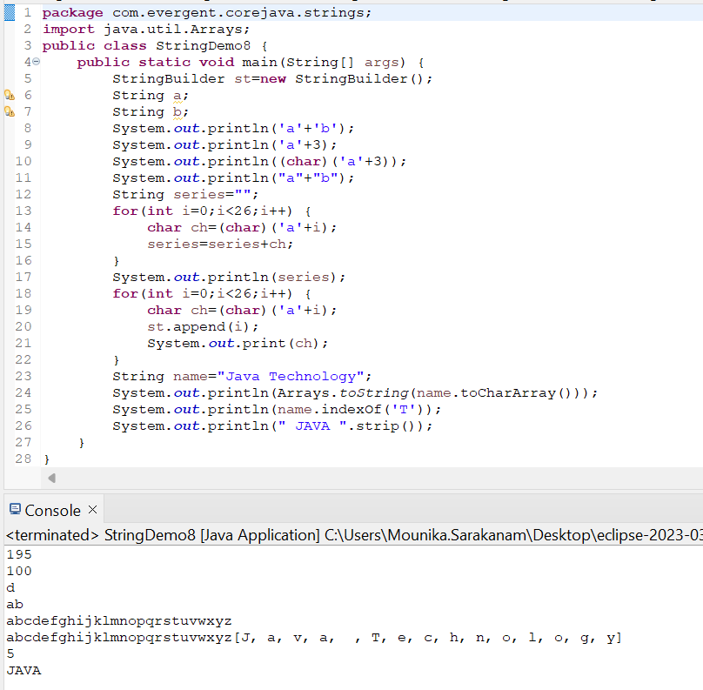

**Day 7: 13-Aug-2024:**

1. **Interfaces:**
   1. Interface is a keyword.
   2. We can declare method signature only but not implementation.
   3. By default all interface methods are abstract.
   4. If any class implements the interface then that class should be override all interface method, otherwise that class will be showing compile time error.
   5. We cannot create object to interface but we can create reference to interface.
   6. We can declare variables inside interface - by default (public static final) variables.
   7. JAVA will support multiple inheritance through interface.
   8. One class can implement interfaces.
   9. One interface extends other interfaces.
   10. We can declare interfaces without methods is called Marker Interfaces.
   11. Example:
       1. clonable
       2. serializable

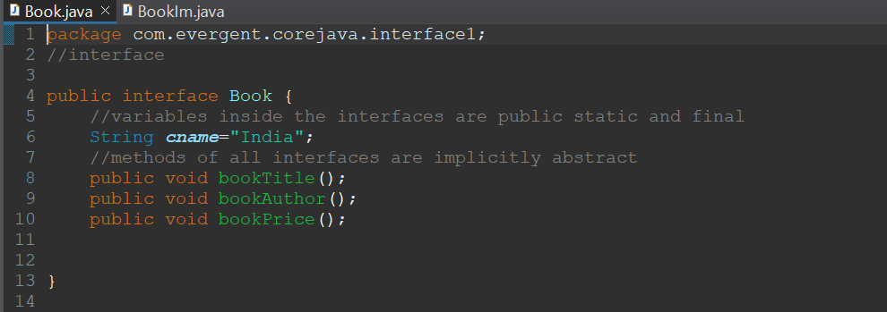

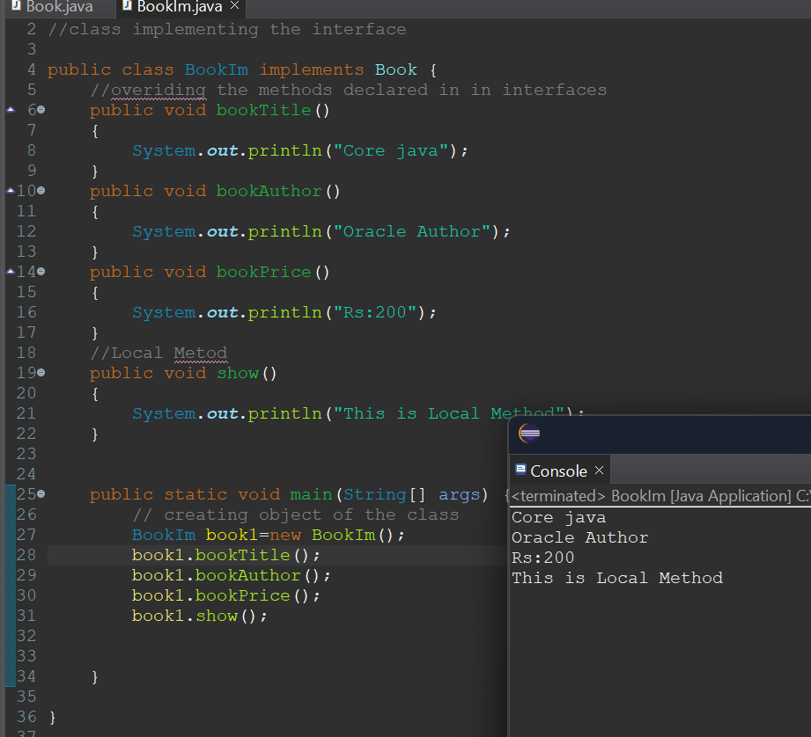

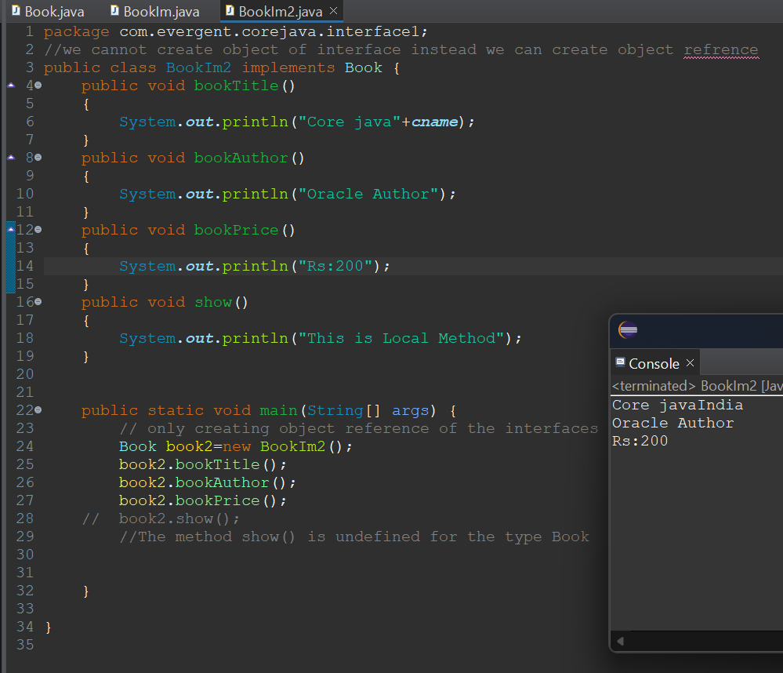

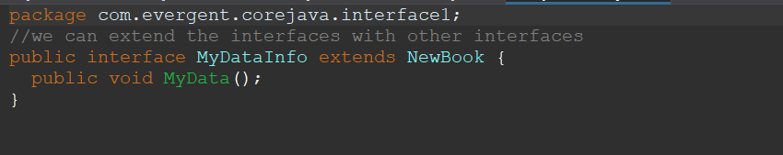

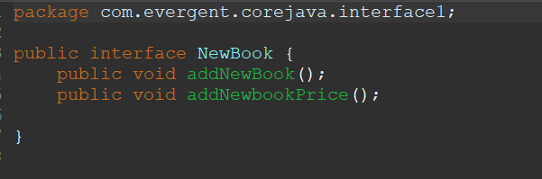

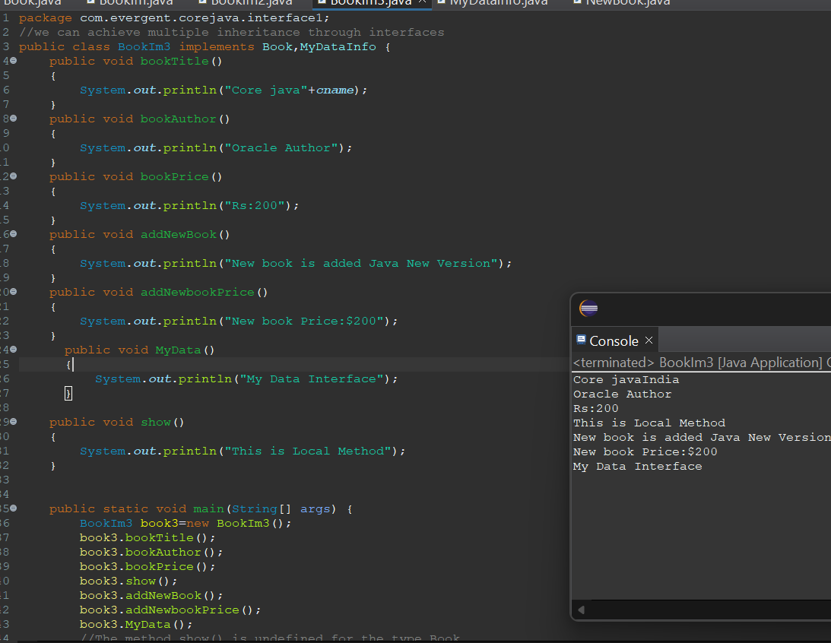

**Day 8: 14-Aug-2024:**

1. **Abstract class:**
   1. Abstract is a keyword.
   2. Abstract class can have abstract methods and concrete methods.
   3. If any class having one abstract method that class should be declared as a abstract keyword, otherwise that class will be showing compile time error.
   4. If any class extends abstract class that class should override all abstract methods, otherwise the class will be showing compile time error.
   5. We cannot create object to abstract class but we can create reference to abstract class.
   6. We have to declare abstract methods explicitly.
   7. We can create constructor to abstract class.
   8. We can access abstract class constructor through the sub-class object creation.

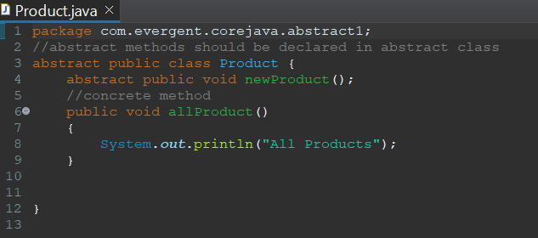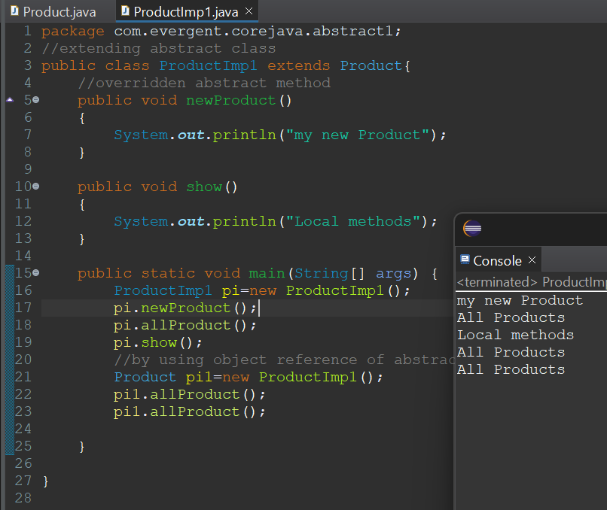

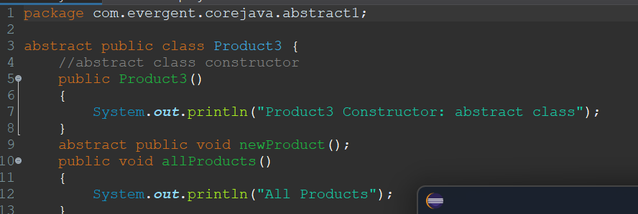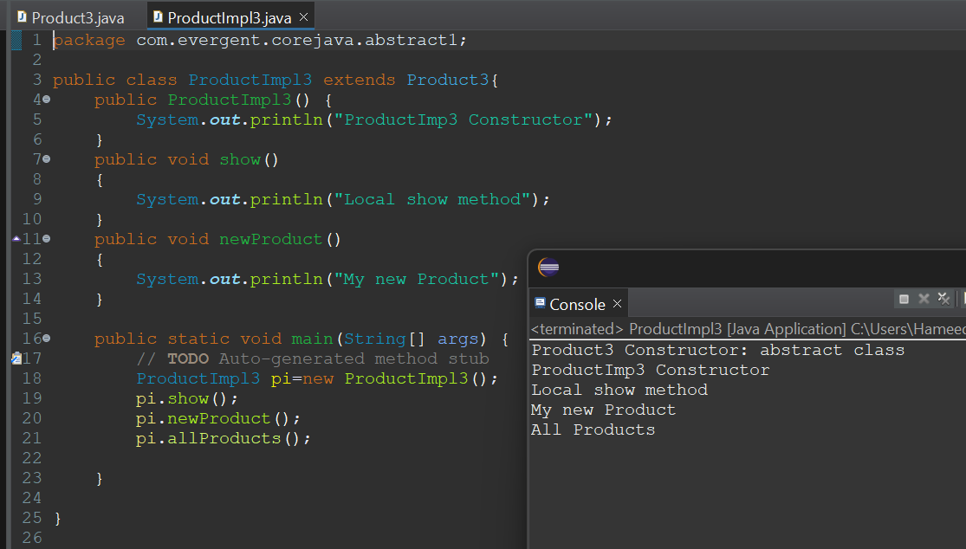

**Day 9: 16-Aug-2024:**

1. Java Concept Test
2. Application design and code

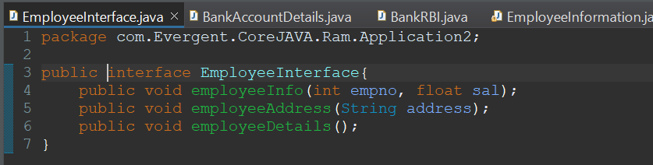

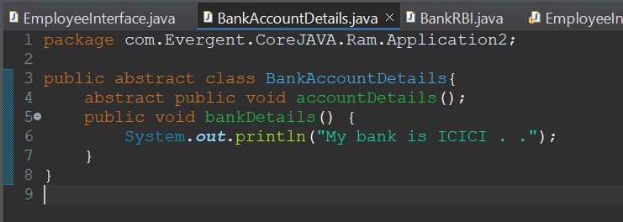

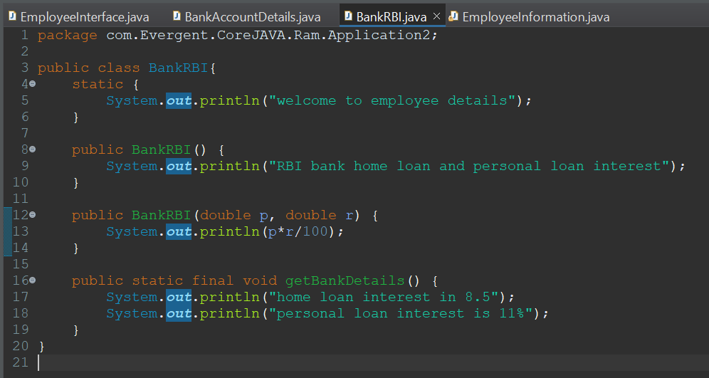

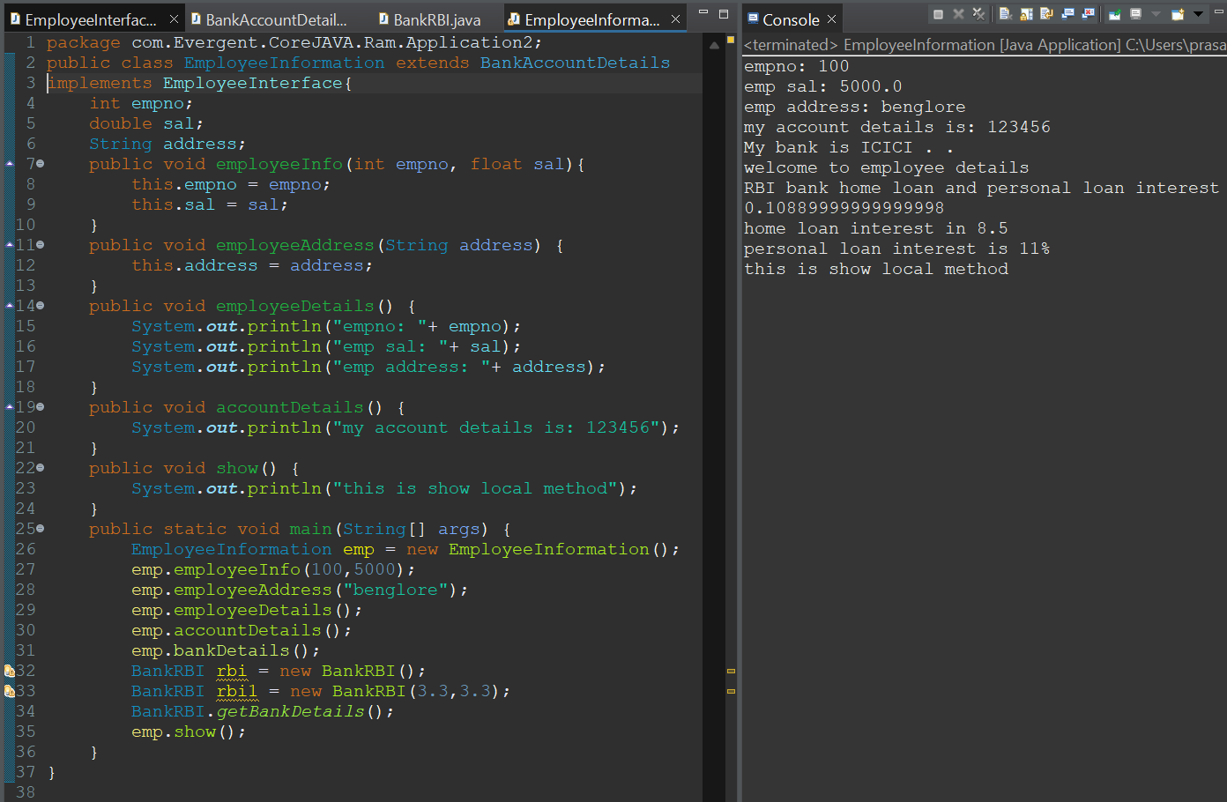

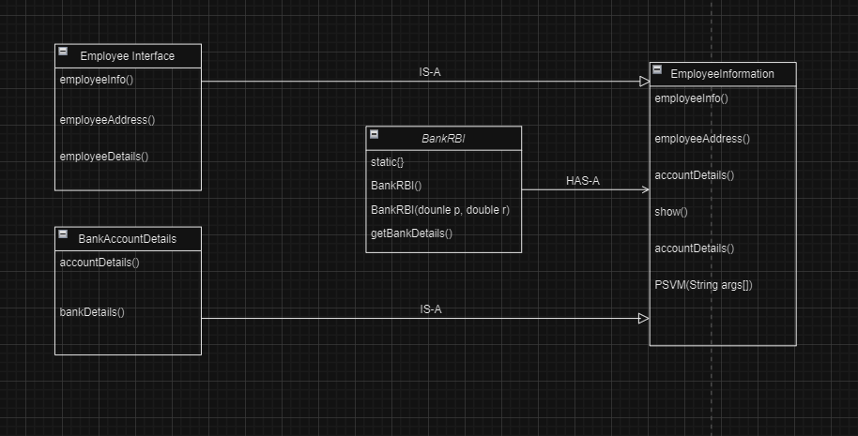

**Day 10: 19-Aug-2024 and Day 11: 20-Aug-2024:**

1. **Exception Handling:**
   1. Exception handling is mechanism
   2. Exceptions are inbuilt mechanism of JAVA
   3. All exceptions are executed while abnormal conditions
   4. Normal flow it won’t execute any exception
   5. Once any exceptions are occurring in java then remaining lines of code are unreachable.
   6. Java.lang.Throwable is super class for exception and error
   7. There are two types of exceptions in JAVA:
      1. Checked exception
      2. Unchecked exception
   8. All checked exceptions are compile time exceptions
   9. All unchecked exceptions are run time exceptions
   10. There are 5 keywords in exception handling:
       1. try
       2. catch()
       3. finally()
       4. throws
       5. throw
   11. Try is for business logic
   12. Catch is for handling exceptions
   13. Finally block, is executed if exception occurs or not
   14. Throws an exception will be executed method by method
   15. Throw is for run time exceptions & will call predefined exceptions
   16. Try followed by either catch or finally block
   17. We should follow exception hierarchical
   18. We can create our own (user-defined) exceptions
   19. Our own exceptions extends exception or run time exception
   20. All exception classes are in to java.lang package
   21. There is two exceptions in class, developer should be handle 1st exception then after 2nd exception will be handled.
   22. Errors cannot be controlled
   23. Handling multiple Execptions with throws
   24. Handling multiple Execptions using multicatch

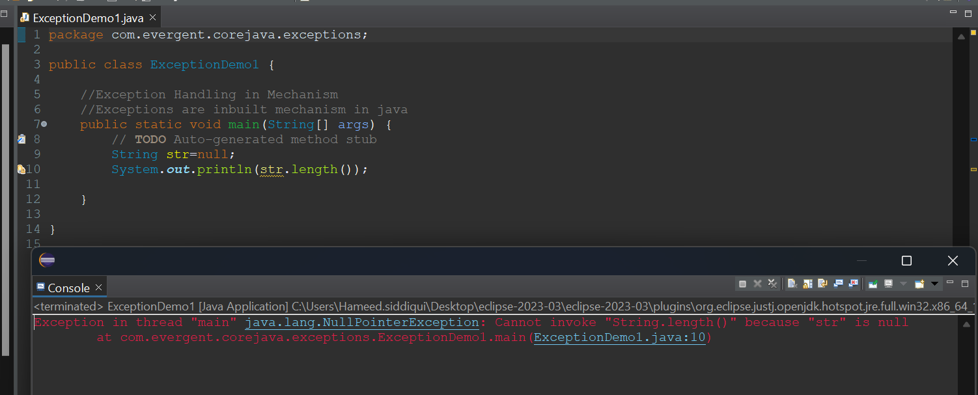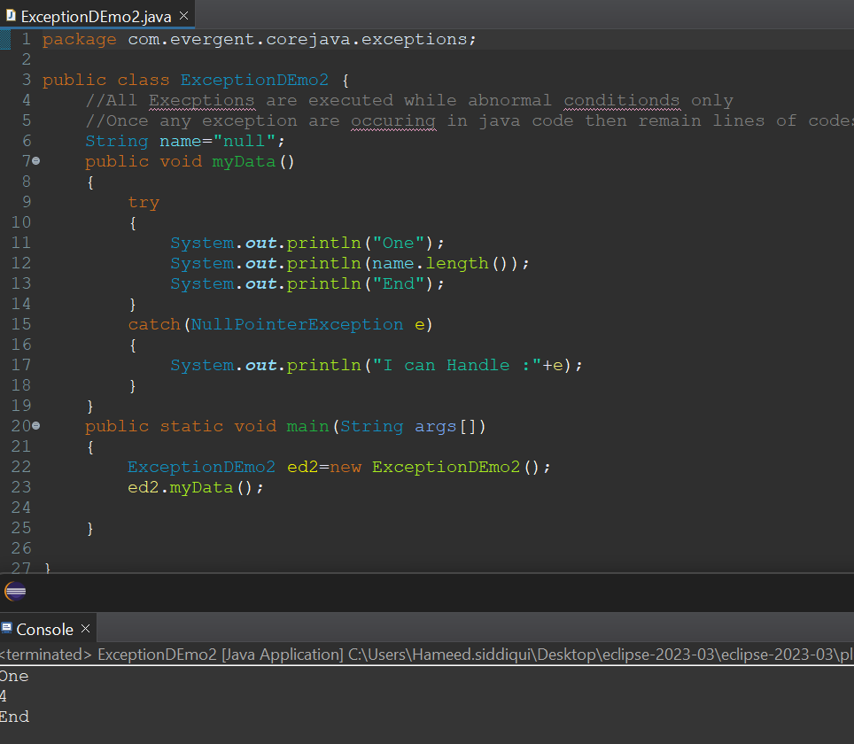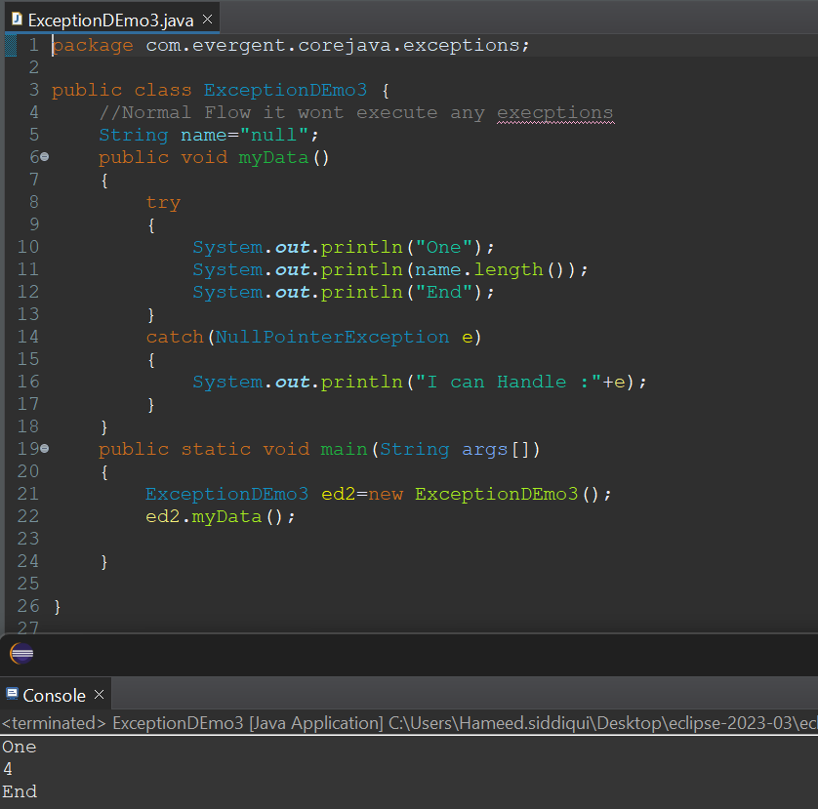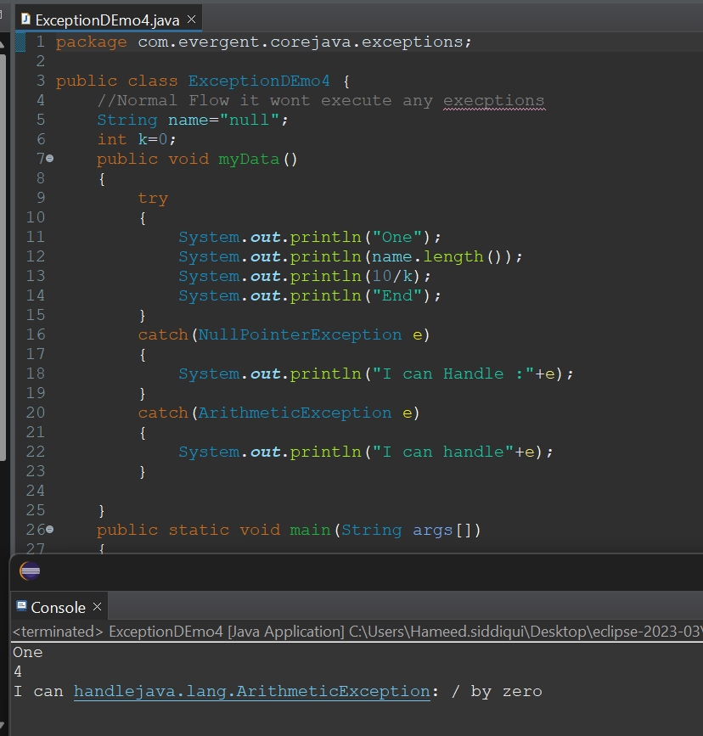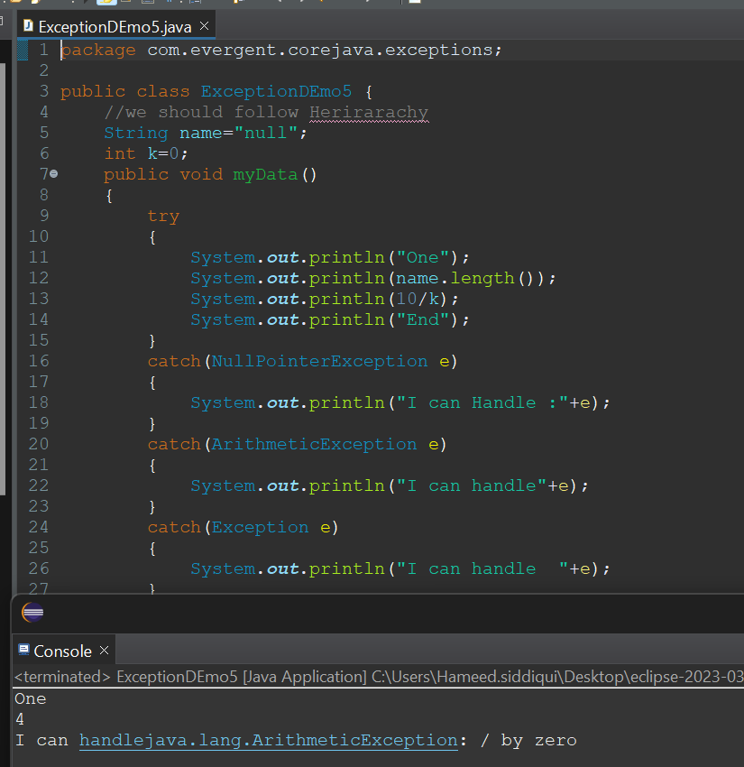

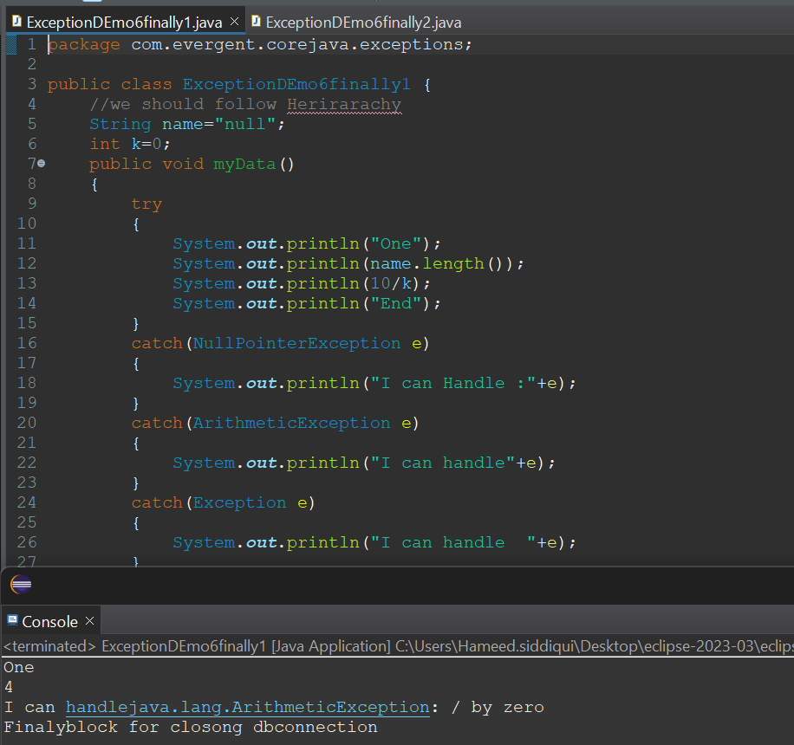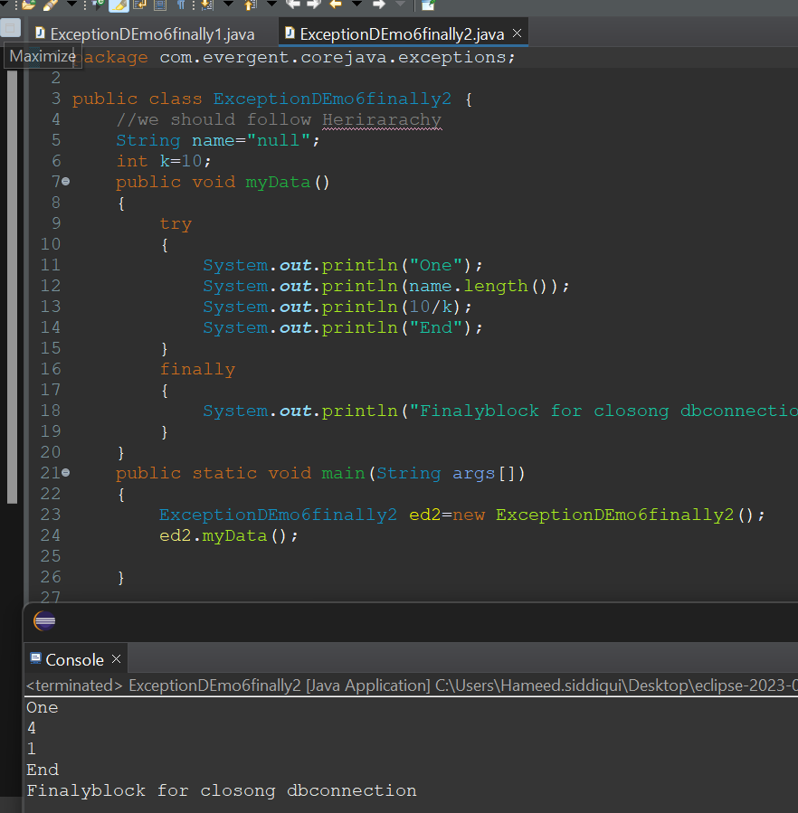

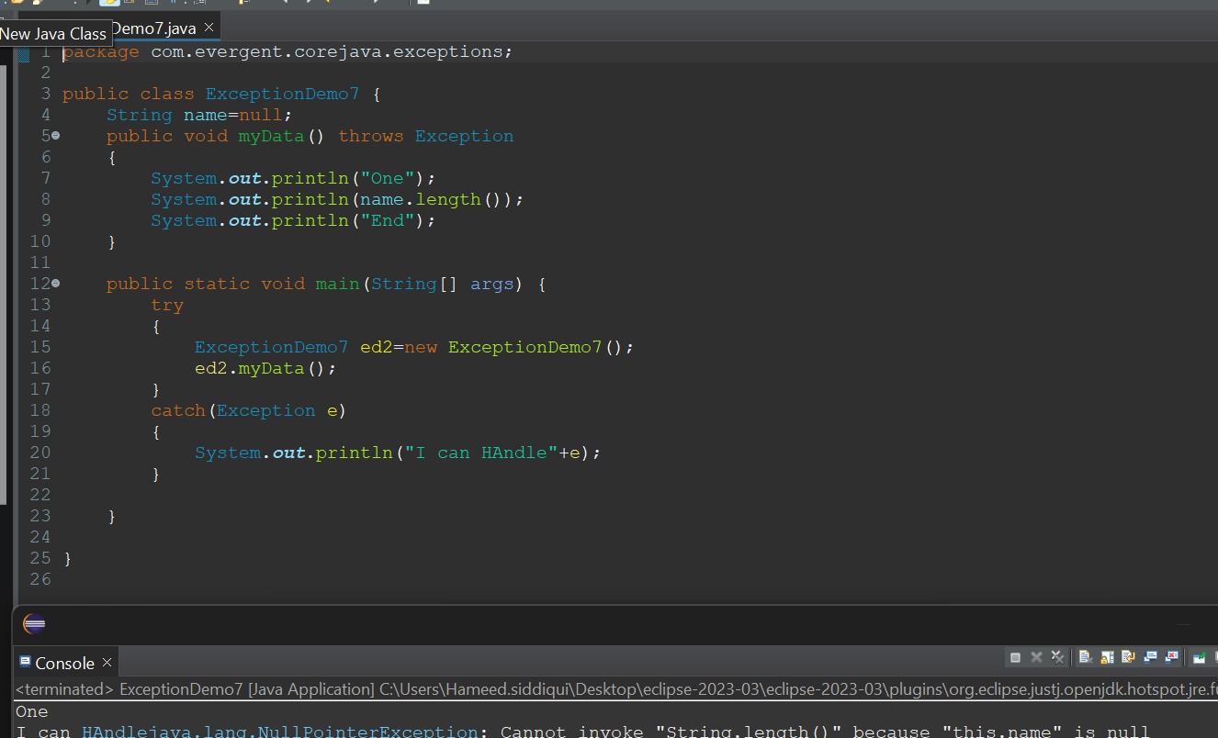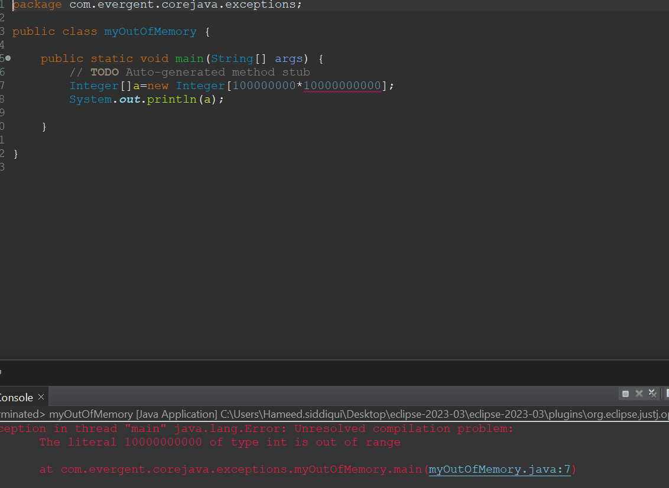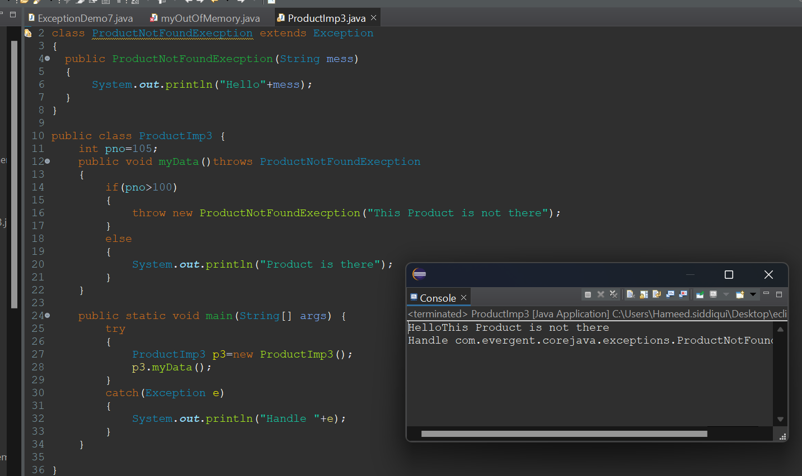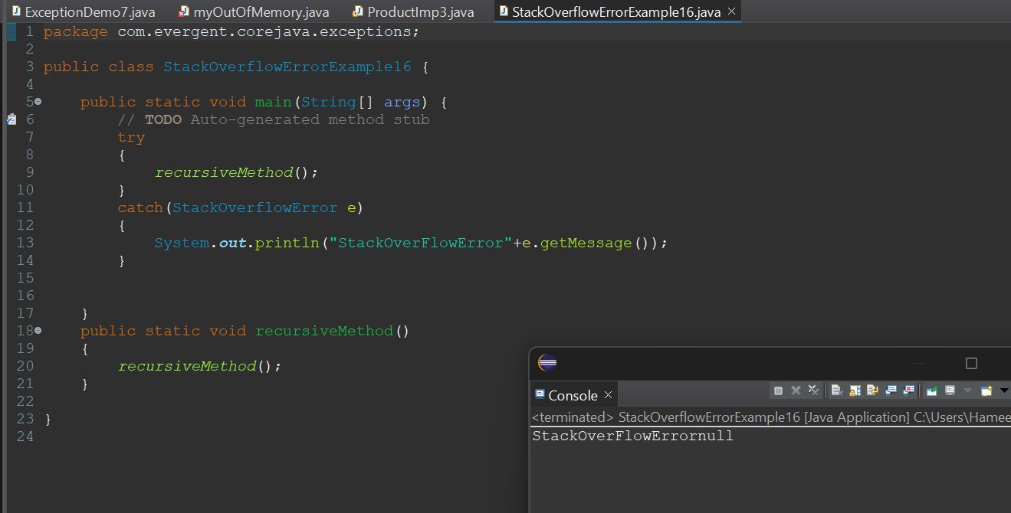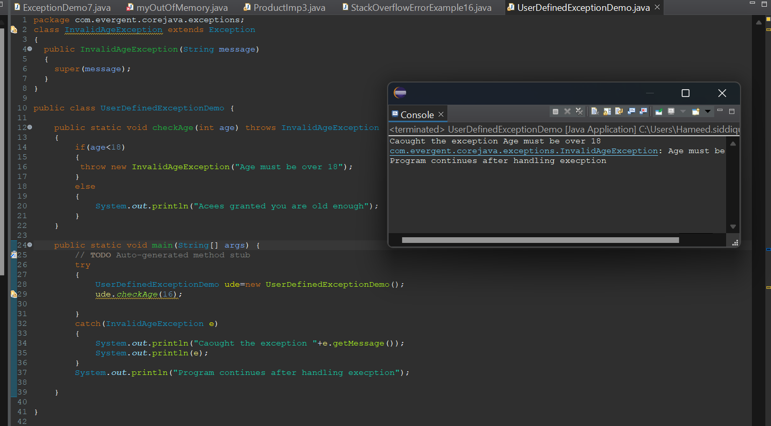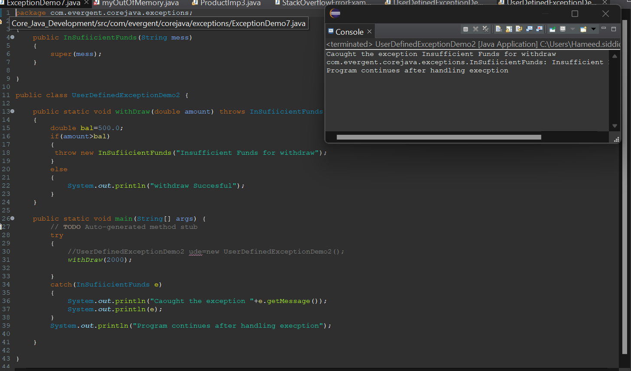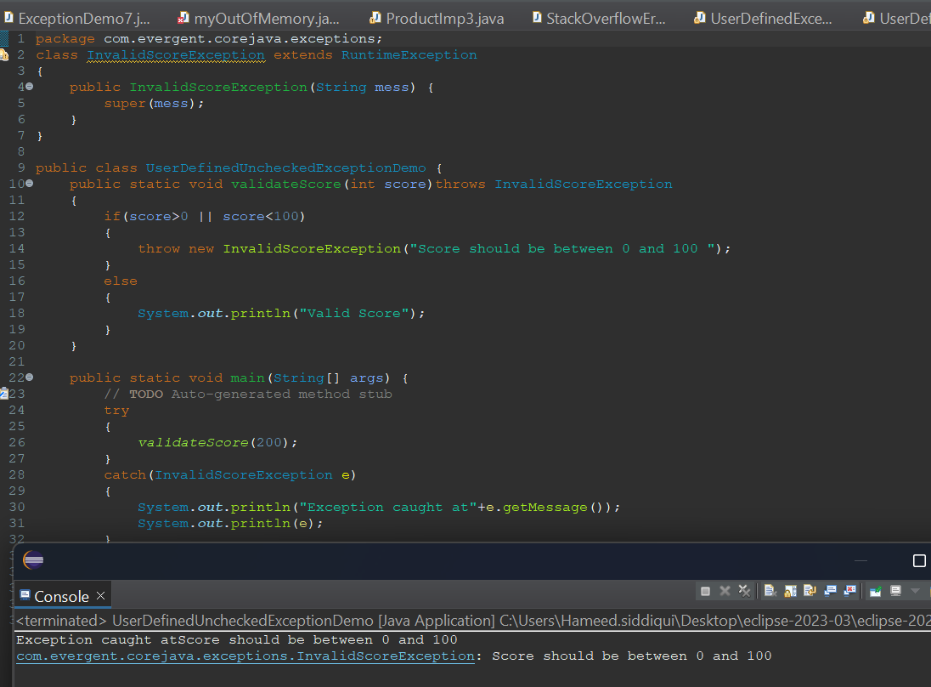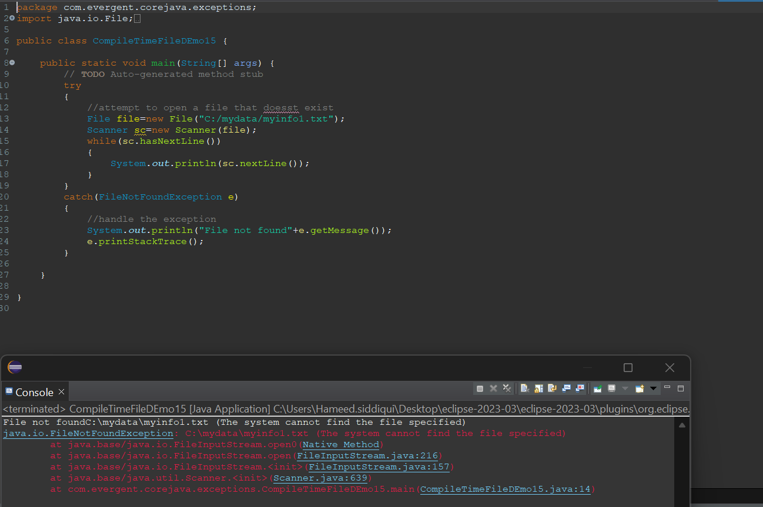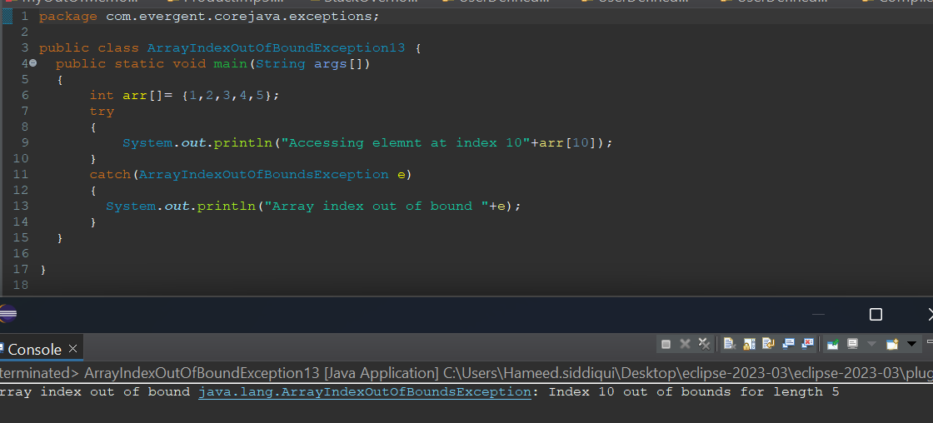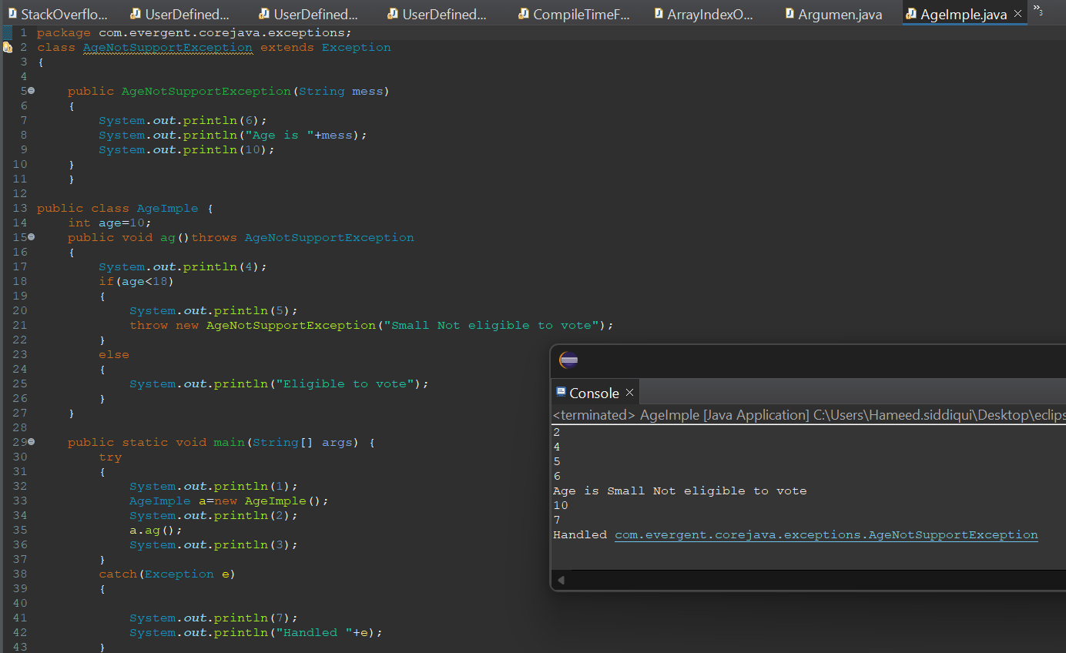

**JAVA Beans:**

1. Java bean is a mechanism
2. Java bean is light weight
3. All attributes are private
4. get/set methods are public
5. Implements java.io.Serializable interface

We can achieve tightly encapsulation through java beans

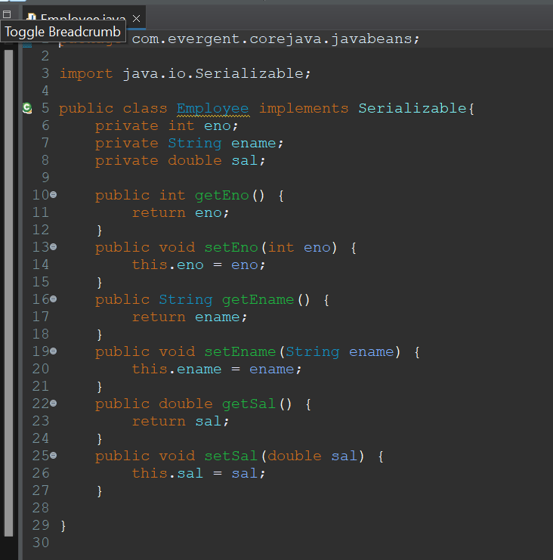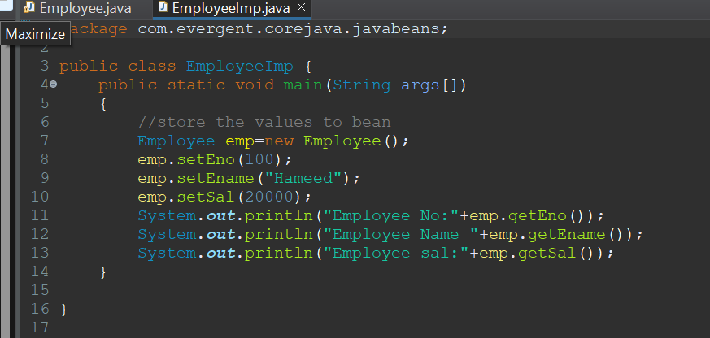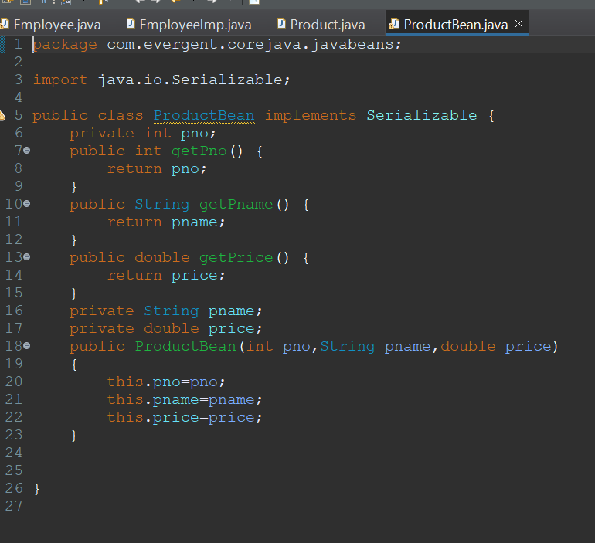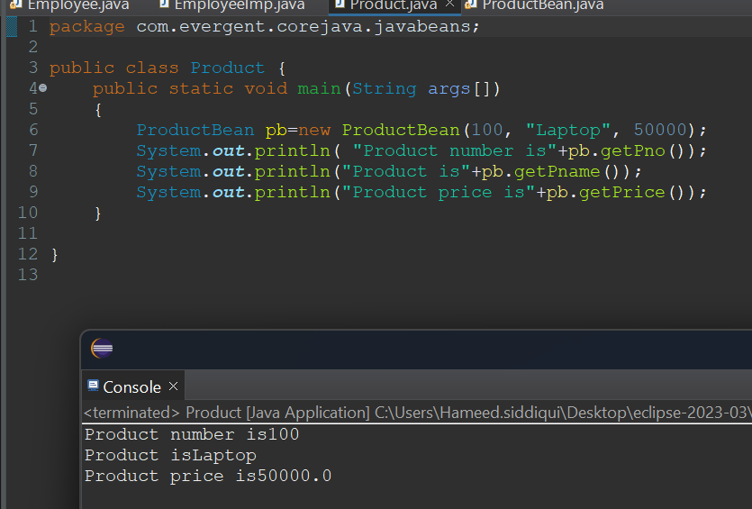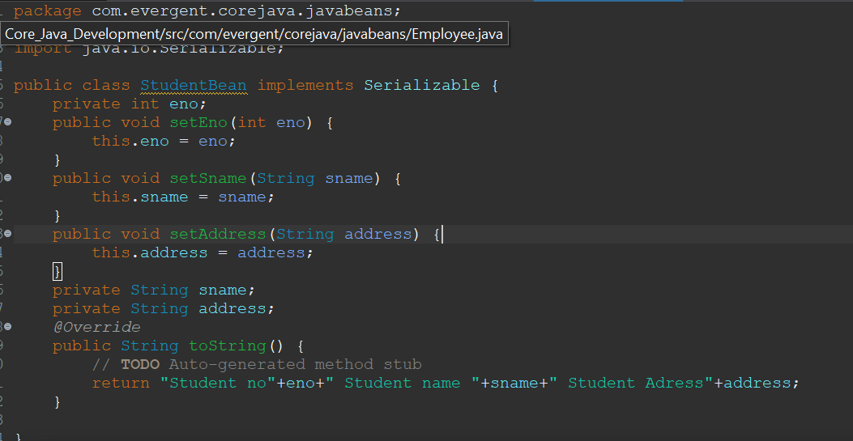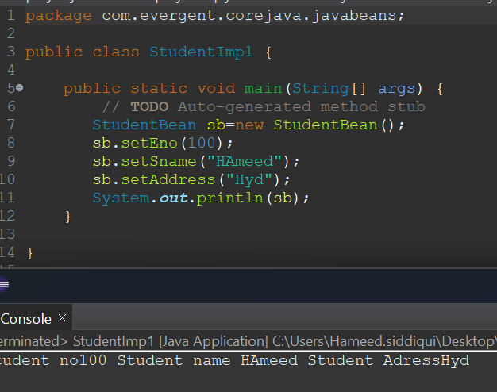

**Git and GitHub:**

Git Commands:

1. Git init
2. Git status
3. Git add .
4. Git commit -m “Uploaded”
5. Git branch
6. Git remote add origin https://github.com/Hameed-85/ETPL703-corejava-evergent.git
7. Git push --force origin master

**COLLECTION FRAMEWORK**

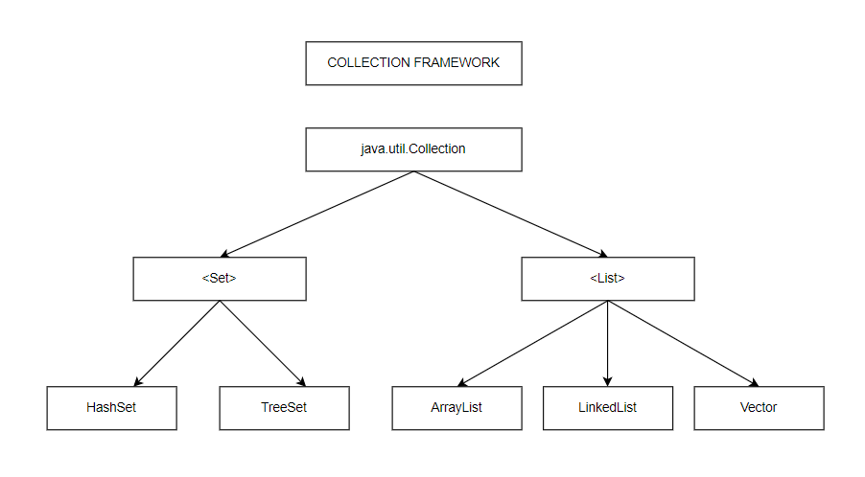

1. Dynamic size growth
2. Stores different data types
3. Contains methods
4. **Set.**
   1. Set items are stored randomly
   2. It doesn’t allow duplicates
5. **List.**
   1. List items are stored orderly
   2. It will allow duplicates

